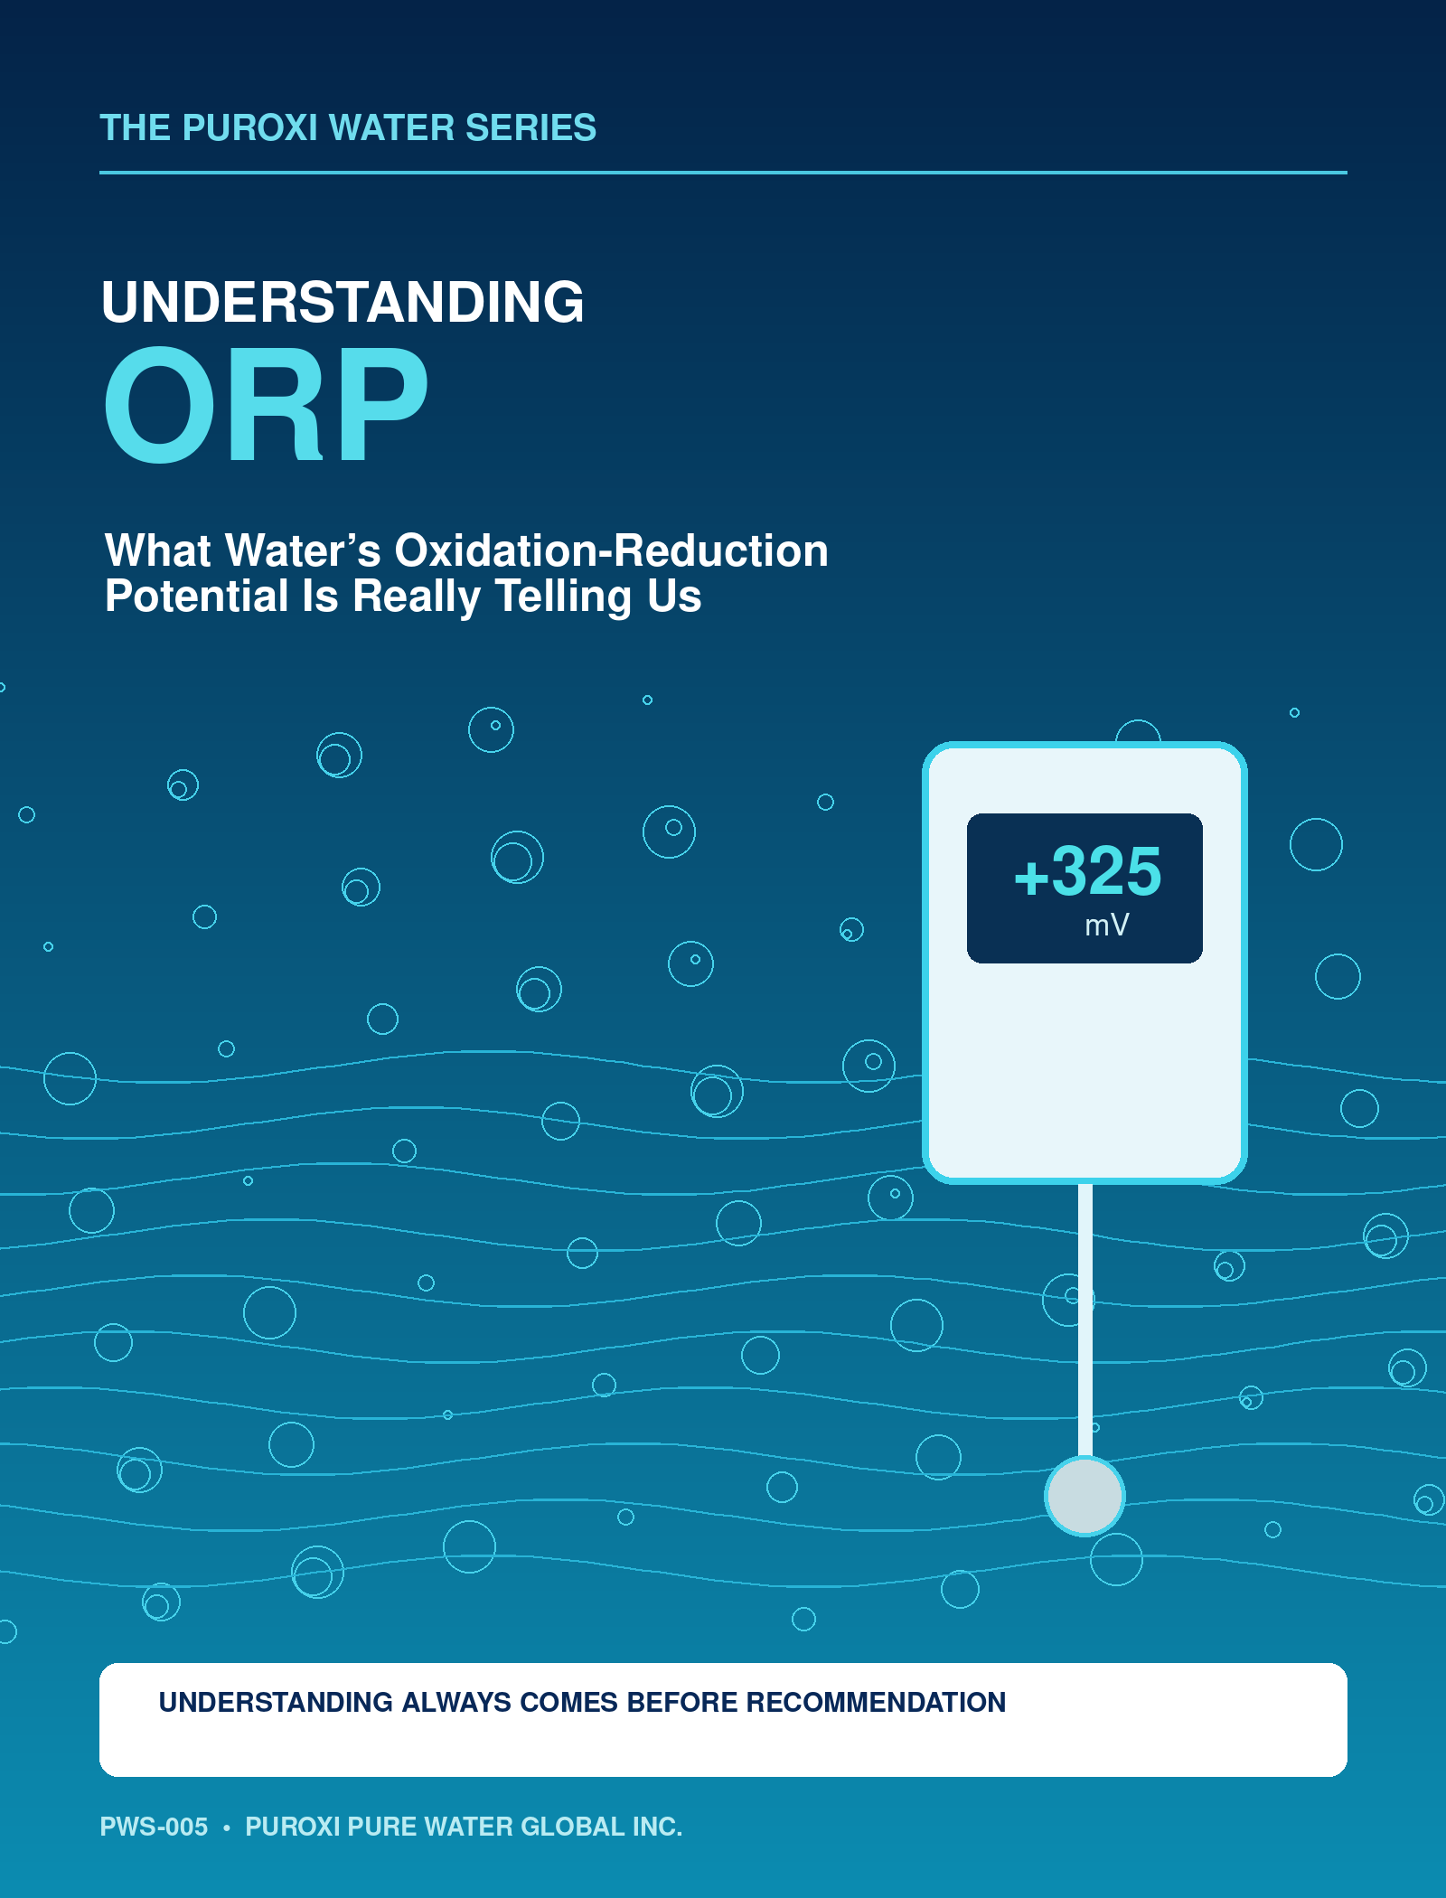

Welcome to PWS-005
Understanding ORP — What Water’s Oxidation-Reduction Potential Is Really Telling Us
Oxidation-reduction potential—usually called ORP—is widely used in water treatment and environmental monitoring. A meter produces a simple millivolt reading, but the chemistry behind that number is anything but simple.
ORP responds to the combined influence of oxidizing and reducing substances that can exchange electrons at the measuring electrode. The result can help operators recognize changing conditions, follow a process, and control certain applications. It cannot, by itself, tell us whether water is clean, safe, healthy, or properly treated.
THE CENTRAL LESSON
ORP is not a universal water-quality score. It is one piece of evidence that gains meaning when interpreted in context.

In this publication, we will explore:
- What oxidation, reduction and ORP mean
- How an ORP electrode produces a millivolt reading
- Why pH, temperature and dissolved oxygen matter
- How ORP behaves in common water applications
- Why trends are often more useful than isolated values
- How oxygen, ozone, chlorine and hydrogen peroxide may influence ORP
- How to collect and interpret readings responsibly
The purpose is not to turn every reader into an electrochemist. It is to make ORP understandable enough to use thoughtfully—and cautiously.
PUROXI PRINCIPLE
Understanding Always Comes Before Recommendation.

1. Oxidation and Reduction
Electron transfer is the foundation of ORP
Oxidation and reduction are paired chemical processes involving the transfer of electrons. When one substance loses electrons, it is oxidized. Another substance must accept those electrons and is reduced.
A substance that accepts electrons is called an oxidizing agent, or oxidant. A substance that donates electrons is called a reducing agent, or reductant. Because the two processes occur together, scientists often use the combined term redox.
Process | Electron action | Simple memory aid
Oxidation | Loses electrons | LEO: Loss of Electrons is Oxidation
Reduction | Gains electrons | GER: Gain of Electrons is Reduction
In real water, many redox couples may be present at once: oxygen and water, chlorine species, iron in different oxidation states, manganese species, sulfur compounds, nitrogen compounds, organic matter, and many others. Some reactions are rapid; others are slow or kinetically limited.
IMPORTANT
A higher ORP does not automatically mean “better,” and a lower ORP does not automatically mean “worse.” The desired condition depends on the process and purpose of the water.

2. What ORP Measures
A voltage produced at an electrode interface
An ORP instrument normally uses an inert sensing surface—commonly platinum or gold—and a reference electrode. The meter measures the electrical potential difference between them and reports it in millivolts (mV).
The sensing electrode does not count every oxidant or reductant in the water. It develops a potential in response to electroactive species able to exchange electrons at its surface. The result reflects the mixed potential established under those conditions.

A positive reading generally indicates a more oxidizing tendency relative to the instrument’s reference system. A negative reading generally indicates a more reducing tendency. But the numerical value must be interpreted carefully because:
- Different reference electrodes use different potentials
- Some meters display values corrected to the standard hydrogen electrode; others do not
- Multiple redox couples can contribute at the same time
- Electrode surface condition can affect response
- Some reactions do not reach equilibrium during measurement
- Flow, mixing, fouling and stabilization time can change the reading
REPORTING RULE
Record the value, temperature, pH, location, time, instrument, reference convention and stabilization method whenever the data may be compared.

3. ORP Is Not a Concentration
One number cannot identify what caused it
ORP is an intensity measurement, not a direct concentration measurement. A reading does not tell us how many milligrams per litre of chlorine, ozone, oxygen, hydrogen peroxide, iron, sulfide, or organic matter are present.
Two waters can show similar ORP readings while containing very different chemical mixtures. Conversely, adding the same dose of an oxidant to two waters can produce different ORP responses because their pH, buffering, organic demand, temperature, and reducing substances differ.

ORP alone cannot reliably answer:
- Is the water microbiologically safe?
- What oxidant is present?
- What is the oxidant concentration?
- Has every treatment objective been achieved?
- Is the water suitable for fish, crops, discharge, drinking, or industrial use?
Where a specific chemical concentration or regulatory result matters, use the appropriate analytical method. ORP may support process control, but it does not replace chlorine residual testing, dissolved-oxygen measurement, microbiological testing, nutrient analysis, metals testing, or application-specific compliance monitoring.
PUROXI INSIGHT
ORP is most useful when it helps explain a process—not when it is asked to replace every other measurement.

4. The Relationship Between ORP and pH
Hydrogen ions participate in many redox reactions
pH and ORP are different measurements, yet they are often closely connected. Many redox reactions involve hydrogen ions, so changing pH can shift the measured potential even when the total amount of an oxidizing substance has not changed.
The direction and magnitude of the shift depend on the chemistry involved. There is no single correction factor that applies to every natural or treated water.

A practical interpretation should therefore ask:
- Did ORP change because an oxidant or reductant changed?
- Did pH change at the same time?
- Did speciation change—for example, between forms of chlorine?
- Did temperature, mixing, organic loading or biological activity also change?
This is one reason ORP setpoints developed at one facility cannot automatically be transferred to another. A site should establish its own relationship between ORP, pH, chemical residuals, process performance, and operating conditions.
MEASUREMENT PAIR
Whenever practical, examine ORP and pH together rather than interpreting either reading in isolation.

5. ORP and Dissolved Oxygen
Related, but not interchangeable
Dissolved oxygen is an important oxidant and often contributes to oxidizing conditions. Aeration or oxygen addition can therefore increase ORP in many systems, especially when oxygen demand is being satisfied.
But dissolved oxygen and ORP are not the same measurement. Water may contain measurable oxygen while other reducing substances continue to influence ORP. In another system, a powerful oxidant may create a high ORP even when dissolved oxygen is not the controlling factor.

When oxygen is introduced, the response may depend on:
- Existing oxygen demand
- Organic loading and microbial respiration
- Mixing and circulation
- Temperature and gas-transfer efficiency
- Reduced iron, manganese, sulfide or other reactive substances
- The location and timing of measurement
A delayed ORP response may indicate that introduced oxygen is first being consumed by chemical or biological demand. That interpretation must be confirmed with other measurements and knowledge of the process.
KEY DISTINCTION
A dissolved-oxygen meter measures oxygen concentration. An ORP meter measures electrochemical potential. One cannot substitute for the other.

6. What Can Raise or Lower ORP?
The reading reflects the balance of many influences
May shift conditions more oxidizing | May shift conditions more reducing
Oxygen transfer or aeration | High organic or biological oxygen demand
Ozone or chlorine addition | Sulfides and other reduced sulfur compounds
Hydrogen peroxide dosing in suitable applications | Ferrous iron and reduced manganese species
Removal of reducing contaminants | Stagnation and oxygen depletion
Improved circulation where reduced zones exist | Decomposition and microbial respiration
These examples describe possible tendencies, not guaranteed outcomes. An added chemical may be consumed immediately, a reaction may be slow, or pH may change at the same time. The measured response depends on the complete water matrix.

Hydrogen peroxide and Puroxi Nano Bubble technology
Hydrogen peroxide is a liquid and is typically dosed upstream of the Puroxi Nano Bubble Nozzle or treatment process. Gases such as oxygen, ozone, carbon dioxide, or nitrogen are introduced through the nozzle gas ports. Hydrogen peroxide should not be fed through those gas ports.
A proposed treatment benefit is that intense mixing through the nozzle may help distribute hydrogen peroxide throughout the water, while persistent oxygen nanobubbles may provide sustained oxygen availability. The effectiveness and economics depend on water chemistry, dose, contact conditions, safety controls, and the treatment objective; site testing is essential. In some applications, hydrogen peroxide can also be simpler to store and integrate than ozone.

7. ORP Across Water Applications
Context determines what the reading means

Drinking water and disinfection
ORP may support monitoring of an established disinfection process, but it does not prove potability or replace disinfectant-residual and microbiological testing.

Wastewater treatment
ORP trends can help reveal transitions between aerobic, anoxic and anaerobic conditions and may support process control when correlated with nitrogen, oxygen and process data.

Aquaculture
ORP may help identify changing oxidation conditions, organic loading or developing reduced zones. Interpret it with dissolved oxygen, pH, temperature, ammonia, nitrite and animal behaviour.

Lakes and reservoirs
Profiles can help reveal stratification and reduced bottom-water conditions. Measurements should be taken by depth and location, not only at the surface.

Agriculture and irrigation
ORP may help track source-water changes and treatment processes, but crop suitability still depends on salinity, sodium, nutrients, pH, alkalinity, pathogens and other factors.

Industrial water
ORP may assist with oxidant control, dechlorination, metal chemistry, corrosion programs or biological control when validated for the specific process.
NO UNIVERSAL TARGET
An ORP value that is useful in one process may be inappropriate—or meaningless—in another.

8. Measuring ORP Responsibly
Good technique matters as much as the meter

Before measurement
- Inspect and clean the electrode according to the manufacturer’s instructions
- Verify performance with an appropriate ORP check solution
- Confirm the reference convention and meter settings
- Record pH and temperature when they affect interpretation

During measurement
- Measure in representative, well-mixed water
- Avoid air exposure when sampling anoxic or reduced water
- Use consistent flow and immersion conditions
- Allow the reading to stabilize; reduced waters may respond slowly
- Avoid touching or abrading the sensing surface improperly

After measurement
- Record time, location, depth and operating condition
- Rinse, store and maintain the probe correctly
- Investigate sudden changes before acting
- Confirm important decisions with complementary measurements
Field ORP measurements can be difficult to reproduce because waters may contain several non-equilibrated redox couples and because sampling itself can expose the water to oxygen. Consistent procedures make trend data more useful.
BEST PRACTICE
Use the same instrument, method, location and stabilization criteria when comparing readings over time.

9. Trends Are Often More Valuable Than Single Readings
Build a site-specific operating picture
A single ORP result is a snapshot. A series of measurements collected consistently can show direction, timing and response.

Useful trend questions include:
- Does ORP fall overnight, during peak production, or after rainfall?
- Does it change with pH, temperature or dissolved oxygen?
- How quickly does it respond when circulation or treatment begins?
- Does a seasonal pattern repeat?
- Do sensor changes correspond with laboratory or process results?
Establish a baseline under known good operating conditions. Then compare future readings against that baseline while tracking related variables and operational events. Statistical control limits may be more useful than borrowing a generic setpoint from another application.
OPERATING PRINCIPLE
Treat ORP as a trend and process signal first. Promote it to a control parameter only after the site-specific relationship has been validated.

10. Common Myths About ORP
Separate useful information from false certainty
Myth: High ORP always means clean water.
Reality: A strong oxidizing condition does not identify contaminants or prove safety.
Myth: ORP tells me how much oxidant is present.
Reality: ORP is not a concentration measurement.
Myth: One target works everywhere.
Reality: Response depends on pH, temperature, chemistry, reference system and application.
Myth: ORP can replace dissolved oxygen.
Reality: They measure different properties and should be used together when both matter.
Myth: A stable number must be correct.
Reality: A fouled or poorly maintained electrode can produce a stable but misleading result.
Myth: Adding oxygen, ozone or peroxide must always raise ORP immediately.
Reality: Demand, kinetics, mixing and measurement location can delay or alter the response.

11. A Practical ORP Investigation
Ask questions before changing treatment
1. Define the application: What must the water accomplish, and what outcome is required?
2. Confirm the measurement: Check the electrode, reference convention, location, stabilization and maintenance.
3. Collect companion data: At minimum consider pH, temperature, dissolved oxygen and application-specific chemistry.
4. Review operating events: Note rainfall, loading, circulation, chemical dosing, production cycles and seasonal changes.
5. Build a trend: Compare readings under similar conditions instead of reacting to a single number.
6. Test the hypothesis: Use controlled trials or bench testing before making major process changes.
7. Verify the outcome: Confirm performance with the measurement that directly represents the objective.
UNDERSTANDING FIRST
The purpose of measurement is not to chase a number. It is to understand the process well enough to make a better decision.

12. Key Lessons
What ORP is really telling us
- ORP describes an oxidation-reduction tendency measured as electrical potential.
- Oxidation and reduction occur together through electron transfer.
- The reading reflects a mixed response from electroactive species at the electrode.
- ORP is not a direct measurement of cleanliness, safety, oxygen, oxidant dose or chemical concentration.
- pH, temperature, dissolved oxygen, chemistry, kinetics and probe condition can all influence interpretation.
- Positive and negative values are relative to the reference system and application.
- Consistent trends are usually more informative than isolated readings.
- Specific treatment and regulatory objectives require specific analytical verification.
- The best ORP setpoint is developed and validated for the actual water and process.
ORP can be an excellent messenger. Like every messenger, it must be understood in context. When operators combine sound measurement practice with companion data and knowledge of the application, ORP becomes a practical tool for recognizing change and improving control.
FINAL THOUGHT
ORP does not give water a grade. It gives us another clue about what is happening within it.
Understanding Always Comes Before Recommendation.

Continue the Conversation
Water is one of our planet’s most valuable resources, and understanding it is the first step toward managing it responsibly.
We hope this publication has provided practical insight into oxidation-reduction potential and has encouraged you to look beyond individual measurements to better understand the water around you.
If you have questions about this publication, would like to discuss a specific application, or have suggestions for future topics in the Puroxi Water Series, we would be pleased to hear from you.

Contact Puroxi
Puroxi Pure Water Global Inc.
British Columbia, Canada
www.puroxi.com
info@puroxi.com
TOGETHER
Let’s continue learning about water—one publication at a time.

About Puroxi
Puroxi Pure Water Global Inc. is a Canadian water technology company dedicated to improving water quality through education, innovation, and practical treatment solutions.
Our mission extends beyond providing products. We believe that understanding water is the foundation of effective water management. Through the Puroxi Water Series, Puroxi Knowledge Centre, Puroxi Academy, and Puroxi Engineering Library, we aim to make water science accessible to municipalities, industry, agriculture, aquaculture, consultants, educators, and students around the world.

Our areas of focus include:
- Nanobubble Technology
- Oxygen Generation
- Ultrasonic Algae Control
- Water Quality Monitoring
- Environmental Water Management
- Drinking Water and Wastewater Treatment
- Industrial Water Systems
- Agriculture and Aquaculture
At Puroxi, we believe that informed decisions lead to better water management, healthier ecosystems, and more sustainable communities.
OUR PHILOSOPHY
Understanding Always Comes Before Recommendation.

Publication Information
Publication Title
Understanding ORP — What Water’s Oxidation-Reduction Potential Is Really Telling Us
Publication Number
PWS-005
Series
Puroxi Water Series
Publisher
Puroxi Pure Water Global Inc., British Columbia, Canada — www.puroxi.com
Copyright
© 2026 Puroxi Pure Water Global Inc. All rights reserved.
No part of this publication may be reproduced, stored in a retrieval system, or transmitted in any form or by any means without prior written permission from the publisher, except for brief quotations used for educational or review purposes.
This publication is intended as an educational resource. While every effort has been made to ensure the accuracy of the information presented, Puroxi Pure Water Global Inc. accepts no responsibility for errors, omissions, or decisions made based on the information contained within this publication. Water quality conditions vary between applications, and professional advice should be obtained where appropriate.

Suggested Citation
Puroxi Pure Water Global Inc. (2026). Understanding ORP — What Water’s Oxidation-Reduction Potential Is Really Telling Us. Puroxi Water Series, PWS-005.

Selected Technical References
- U.S. Environmental Protection Agency. Field Measurement of Oxidation-Reduction Potential (ORP), FSBPROC-113-R5, 2024.
- U.S. Geological Survey. National Field Manual for the Collection of Water-Quality Data, Chapter A6.5: Reduction-Oxidation Potential (Electrode Method).
- U.S. Geological Survey. Oxidation/Reduction (Redox): Water Resources science overview.
- Hach Company. Introduction to Oxidation Reduction Potential Measurement; and Method 10228, Oxidation Reduction Potential (ORP).

