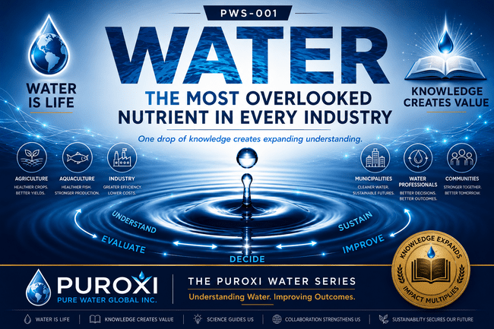

THE PUROXI WATER SERIES
PWS-003
Why pH Matters
Category: Water Science
First Edition | July 2026
Published by Puroxi Pure Water Global Inc.
Water Is Life
Knowledge Creates Value

About the Puroxi Water Series
The Puroxi Water Series (PWS) is an educational publication designed to improve understanding of water through science, practical experience and thoughtful discussion.

AT A GLANCE
- Estimated Reading Time: 25-30 minutes
- Audience: Agriculture • Aquaculture • Municipalities • Industry • Consultants • Students
- Understand what pH really means.
- Learn why pH influences the entire water system.
- Discover why temperature, dissolved oxygen, and pH must be considered together.
- Separate common myths from water science.
- Learn practical strategies for managing pH.
- Understand the Puroxi philosophy: Understanding Always Comes Before Recommendation.

Why This Publication Matters
Without water, there would be no life. Every person, every animal, every crop, every fish, every forest and every ecosystem depends upon it. Water is the foundation upon which life itself depends. Around the world, investment in water treatment and reuse reflects its growing importance. Yet one question remains: Do we truly understand the water we depend upon every day?
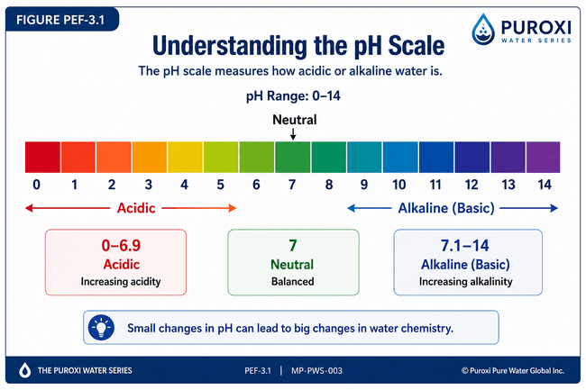

CHAPTER 1

What Is pH?
Most people have heard of pH, yet few truly understand what it represents or why it is so important.
Ask someone what pH means and they will often reply, "It tells you whether water is acidic or alkaline." While that answer is technically correct, it is only a small part of the story.
In reality, pH is one of the most important measurements in water science because it influences almost every chemical and biological process that occurs in water. It affects corrosion, scale formation, nutrient availability, disinfection, biological activity, and the performance of countless water treatment processes.
Understanding pH is not about memorizing a number. It is about understanding how water behaves.

What Does pH Mean?
The term pH stands for "potential of hydrogen" and is a measure of the concentration of hydrogen ions (H⁺) present in water.
Hydrogen ions naturally exist in all water. The concentration of these ions determines whether water is acidic, neutral, or alkaline.
- A low pH indicates a higher concentration of hydrogen ions and more acidic water.
- A high pH indicates a lower concentration of hydrogen ions and more alkaline water.
- A neutral pH represents a balance between hydrogen ions and hydroxide ions under standard conditions.
Although this definition is scientifically accurate, what matters most in practical water management is understanding how changes in pH influence the behaviour of the water.

The pH Scale
The pH scale ranges from 0 to 14.
- Below 7 — Acidic
- Approximately 7 — Neutral
- Above 7 — Alkaline (Basic)
One of the most misunderstood aspects of pH is that it is not a linear scale.
It is a logarithmic scale.
This means that each whole number represents a tenfold change in hydrogen ion concentration.
For example:
- Water at pH 6 is ten times more acidic than water at pH 7.
- Water at pH 5 is one hundred times more acidic than water at pH 7.
- Water at pH 4 is one thousand times more acidic than water at pH 7.
Likewise, water at pH 8 is ten times more alkaline than water at pH 7.
This is why what appears to be a small change in pH can produce significant changes in water chemistry.

Why Does Water Have Different pH Values?
No two water sources are identical.
The pH of water is influenced by many natural and human-made factors, including:
- Geology
- Dissolved minerals
- Carbon dioxide
- Rainfall
- Groundwater recharge
- Biological activity
- Temperature
- Agricultural practices
- Industrial activity
- Wastewater discharges
Every one of these influences contributes to the unique fingerprint of the water.
This is one of the reasons we say:
Every water source has its own fingerprint and DNA.

pH Is Not Good or Bad
One of the biggest misconceptions about pH is that there is one "perfect" number.
There isn't.
The ideal pH depends entirely on the intended use of the water.
Water used for drinking, irrigation, livestock, aquaculture, industrial cooling, wastewater treatment, and environmental restoration may all have different optimum operating ranges.
The goal is not to force every water source to the same pH.
The goal is to understand what conditions best support the desired outcome.

DID YOU KNOW?
A change of only one pH unit represents a tenfold change in hydrogen ion concentration. Small changes in pH can therefore produce large changes in water chemistry and treatment performance.

PRACTICAL TIP
Never interpret a pH result by itself.
Always consider the source of the water, seasonal conditions, temperature, dissolved oxygen, alkalinity, hardness, and the purpose for which the water will be used.

QUOTE
pH is not simply a number—it is one of the most important conversations your water is having with you.

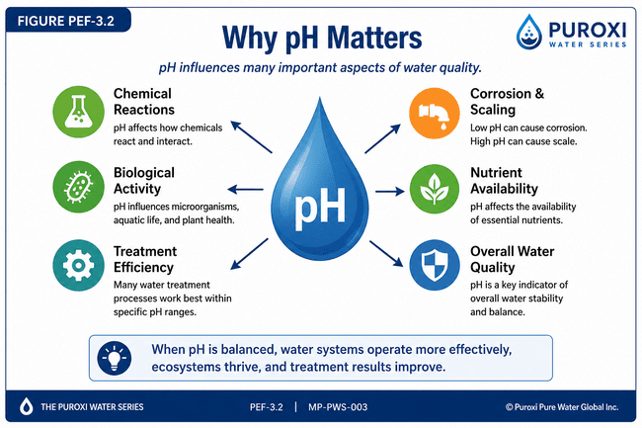

CHAPTER 2

Why pH Is More Than Just a Number
If pH simply told us whether water was acidic or alkaline, it would still be an important measurement.
But pH influences far more than that.
It affects virtually every chemical, biological, and physical process that takes place in water.
From the moment water enters a well, lake, river, reservoir, municipal treatment plant, irrigation system, livestock operation, aquaculture facility, or industrial process, pH begins influencing how that water behaves.
Understanding pH is therefore not about achieving a specific number.
It is about understanding the role that number plays within the entire water system.

Corrosion
Water chemistry plays a major role in corrosion.
When water becomes aggressive, it may accelerate the deterioration of pipes, pumps, valves, fittings, storage tanks, and other infrastructure.
Corrosion can shorten equipment life, increase maintenance costs, and in some cases contribute to metals entering the water supply.
Although corrosion depends on many factors, pH is one of the key parameters influencing its development.

Scale Formation
At the opposite end of the spectrum, water chemistry may encourage the formation of mineral scale.
Scale deposits gradually reduce pipe diameter, restrict water flow, decrease heat transfer efficiency, increase energy consumption, and shorten equipment life.
Managing scale requires understanding the relationship between pH, hardness, alkalinity, temperature, and mineral saturation.

Biological Activity
Every microorganism has preferred environmental conditions.
As pH changes, biological communities often change as well.
Some organisms become more active.
Others decline.
These shifts influence water clarity, nutrient cycling, odours, and overall biological balance.
Rather than viewing pH as an isolated measurement, it should be considered one of the environmental factors that helps shape the entire ecosystem.

Nutrient Availability
One of the most valuable lessons we learned through years of practical field experience is that water chemistry directly influences how efficiently nutrients are utilized.
Whether working with livestock, crops, fruit, vegetables, greenhouse operations, or aquaculture, properly adjusting water chemistry for the application often produced measurable improvements in performance.
Water is not simply a carrier of nutrients.
It participates in every biological process taking place within the plant or animal.

Water Treatment
Many treatment technologies perform differently depending on the pH of the water.
Oxidation.
Disinfection.
Coagulation.
Metal removal.
Chemical reactions.
Biological treatment.
All are influenced by water chemistry.
Attempting to solve a water quality problem without first understanding pH often results in inconsistent or disappointing outcomes.

Equipment Performance
Water affects more than the water itself.
It affects every piece of equipment that comes into contact with it.
Pumps.
Boilers.
Cooling towers.
Heat exchangers.
Filters.
Irrigation systems.
Piping.
Valves.
Good water chemistry protects not only the water but also the equipment and infrastructure that depend upon it.

The Bigger Picture
One of the most important lessons we have learned is that pH should never be viewed in isolation.
Temperature.
Dissolved oxygen.
Alkalinity.
Hardness.
Carbon dioxide.
Biological activity.
Nutrients.
Seasonal change.
All interact continuously.
Changing one parameter often influences several others.
Successful water management begins by understanding the complete system rather than focusing on a single measurement.
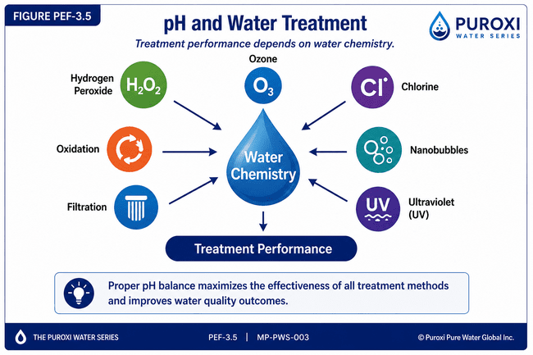

THE PUROXI PRINCIPLE
Never manage one water parameter in isolation. Manage the water as a complete system.

QUOTE
Understanding pH is not about chasing a number. It is about understanding how that number influences the entire water system.

DID YOU KNOW?
In many natural water bodies, increasing water temperature combined with rising pH can coincide with increased biological activity, odours, water discolouration, and declining overall water quality. These changes often occur together rather than independently.

PRACTICAL TIP
When reviewing a laboratory report, never look at pH by itself. Always evaluate it alongside temperature, dissolved oxygen, alkalinity, hardness, conductivity, and the intended use of the water. Understanding the relationships between these parameters leads to better decisions than evaluating any single measurement alone.

CHAPTER 3

Why pH 7 Isn't Always Perfect
One of the biggest misconceptions in water treatment is the belief that pH 7 is always the ideal target.
It isn't.
While a pH of approximately 7 is considered neutral under standard laboratory conditions, neutrality should never be confused with optimal performance.
The best pH depends entirely on what you are trying to accomplish.
Water is used in many different ways.
It supports people.
It supports livestock.
It grows crops.
It raises fish.
It cools industrial equipment.
It carries out chemical reactions.
It disinfects drinking water.
Because each application is different, the ideal water chemistry may also be different.
This is one of the most important lessons we have learned through years of practical field experience.
Rather than asking,
"What is the perfect pH?"
we learned to ask,
"What pH best supports the outcome we are trying to achieve?"
That single question changed the way we approached water treatment.

Drinking Water
For drinking water, maintaining stable water chemistry is often more important than trying to achieve one exact pH value.
A properly balanced water supply helps protect plumbing systems, minimizes corrosion, improves taste, and supports effective treatment processes.
The objective is not to chase a number.
The objective is to provide safe, stable, and reliable water.

Agriculture
Agriculture taught us one of the most valuable lessons about pH.
Different crops.
Different soils.
Different irrigation water.
Different production goals.
Each may benefit from different water chemistry.
Successful producers understand that water management is part of crop management.
Water should support plant health rather than limit it.

Livestock
The same principle applies to livestock production.
Different species.
Different stages of production.
Different nutritional requirements.
Different management objectives.
Over nearly two decades of working with agricultural producers, we found that adjusting water chemistry to suit the specific application often produced measurable improvements in overall performance.
Rather than searching for one universal pH, we focused on achieving the conditions that best supported the desired production outcome.

Aquaculture
Fish, shrimp, shellfish, and other aquatic organisms are particularly sensitive to changes in water chemistry.
Unlike terrestrial animals, they live continuously within the water itself.
Even relatively small changes in water quality may influence stress, feeding behaviour, oxygen availability, biological activity, and overall health.
Maintaining stable water conditions is often more important than making frequent adjustments in an attempt to reach a single target number.

Industrial Water
In industrial applications, pH influences equipment protection, chemical reactions, heat transfer, scaling, corrosion, and operating efficiency.
The optimum operating range depends on the process rather than a universal standard.
Understanding the objective remains the first step.

Environmental Water
Lakes.
Reservoirs.
Wetlands.
Rivers.
Stormwater ponds.
Wastewater lagoons.
Natural water bodies continuously change as temperature, sunlight, biological activity, rainfall, nutrient loading, and seasonal conditions evolve.
Attempting to force nature toward one number is rarely the objective.
Understanding why pH is changing is usually far more valuable than simply changing it.

THE FOUNDER'S NOTEBOOK

The Right pH Depends on the Goal
One of the biggest lessons we learned over the years was that there is rarely one perfect water chemistry for every application.
Instead of trying to make every water source reach the same number, we began adjusting water chemistry to support the objective we were trying to achieve.
Sometimes the goal was improving livestock performance.
Sometimes it was supporting crop production.
Sometimes it was improving water quality.
Sometimes it was reducing odours or improving treatment efficiency.
Every application was different.
The lesson was always the same.
Understand the objective first.
Only then can you determine whether adjusting pH will help achieve it.
That philosophy continues to guide the way we approach water today.

PUROXI INSIGHT
The best pH is not the one found in a textbook. The best pH is the one that best supports your objective while maintaining a healthy, balanced water system.

DID YOU KNOW?
Two water sources with exactly the same pH can behave very differently because of differences in alkalinity, hardness, dissolved minerals, temperature, biological activity, and other water quality parameters.

PRACTICAL TIP
Avoid chasing a single pH value simply because someone says it is "ideal." Always ask:
- What is the purpose of this water?
- What outcome am I trying to achieve?
- Is adjusting pH the correct solution, or is another water quality factor influencing the result?
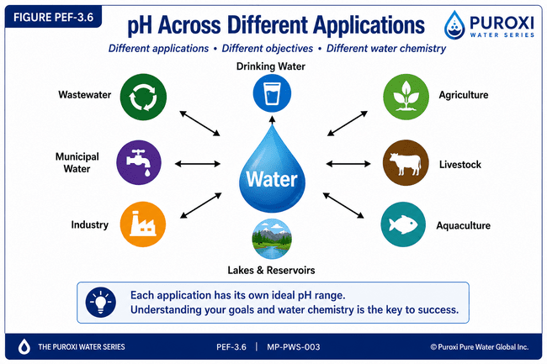

QUOTE
The goal is not to make every water source the same. The goal is to create the best possible water for the job it needs to do.

CHAPTER 4

What Causes pH to Change?
One of the most common questions people ask is:
"Why did my pH change?"
The answer is both simple and complex.
Water is constantly changing.
Unlike many people believe, pH is not a fixed characteristic. It responds continuously to both natural processes and human activity. A water source that tests one way today may produce different results next month or next season.
Understanding what causes pH to change is often more valuable than simply trying to correct the number.
At Puroxi, we have found that asking "Why did it change?" usually leads to better long-term solutions than asking "How do I change it back?"

Nature Is Always Working
Every drop of water is influenced by its surroundings.
As water travels through the environment it dissolves minerals, absorbs gases, supports biological activity, and responds to seasonal weather conditions.
Its chemistry is constantly evolving.
That is why no two water sources are exactly alike.

Rainfall
Rainwater naturally absorbs gases from the atmosphere before reaching the ground.
As it travels across the landscape or infiltrates into the soil, it continues changing as it interacts with rocks, minerals, vegetation, and microorganisms.
Heavy rainfall may temporarily change the chemistry of lakes, ponds, reservoirs, rivers, and shallow groundwater.

Geology
The rocks beneath our feet play a major role in determining water chemistry.
Water flowing through limestone behaves differently than water moving through granite, sandstone, or volcanic rock.
As water slowly dissolves naturally occurring minerals, its chemistry continues to evolve.
This is one reason why two neighbouring wells can produce remarkably different water.

Carbon Dioxide
Carbon dioxide is one of the most important natural influences on pH.
It is continuously entering and leaving water.
Fish.
Plants.
Bacteria.
Algae.
Respiration.
Photosynthesis.
Atmospheric exchange.
All influence carbon dioxide levels.
As carbon dioxide changes, pH often changes with it.

Temperature
Temperature influences almost every process occurring in water.
As temperature rises, biological activity generally increases.
Microorganisms become more active.
Algae may grow more rapidly.
Chemical reactions often occur more quickly.
These changes can influence pH, dissolved oxygen, nutrient cycling, and overall water quality.
Temperature should never be viewed as an isolated measurement.
It is one of the driving forces behind changing water chemistry.

Biological Activity
Healthy water contains life.
Bacteria.
Algae.
Aquatic plants.
Fungi.
Zooplankton.
Microorganisms.
Every living organism interacts with the surrounding water.
As biological activity changes, pH may also change.
This is particularly noticeable in ponds, lakes, reservoirs, wastewater systems, and aquaculture operations.

Human Activity
Human activity has become an increasingly important influence on water quality.
Agriculture.
Urban development.
Industrial operations.
Stormwater runoff.
Wastewater discharges.
Changing land use.
These activities may alter water chemistry long before visible changes appear.
One of the reasons routine monitoring has become so important is that many changes cannot be detected simply by looking at the water.

Seasonal Change
Every season tells a different story.
Spring snowmelt.
Summer heat.
Autumn leaf fall.
Winter dormancy.
Each season influences water chemistry differently.
Some changes occur gradually.
Others occur surprisingly quickly.
Understanding these seasonal cycles often helps explain why pH appears to fluctuate throughout the year.

THE FOUNDER'S NOTEBOOK

Water Never Stands Still
One of the greatest lessons water has taught us is that it is never truly the same from one day to the next.
Many people assume that because a laboratory report looked good last year, the water must still be the same today.
Experience has taught us otherwise.
Weather changes.
Temperature changes.
Land use changes.
Biological activity changes.
Groundwater changes.
Even the aquifer supplying a well may evolve over time.
Water is constantly responding to the environment around it.
That is why routine observation is just as important as laboratory testing.
Understanding trends often reveals far more than a single laboratory report ever could.

PUROXI INSIGHT
Water is constantly adapting to its environment. The better we understand those changes, the better decisions we can make.

DID YOU KNOW?
Many water quality problems develop gradually over months or even years before they become visible. Regular monitoring often identifies these trends long before they become serious.

PRACTICAL TIP
Don't compare today's water only to yesterday's results.
Compare it to previous seasons, previous years, and changing environmental conditions.
Water tells a much clearer story when viewed over time rather than as a single snapshot.

QUOTE
Water is not static. It is one of the most dynamic natural systems on Earth. Understanding change is the key to understanding water.
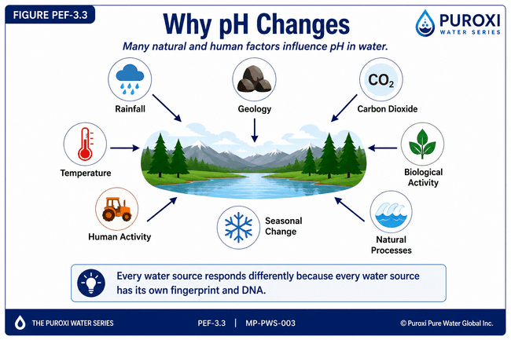
Changing Water Chemistry
Every water source responds differently because every water source has its own fingerprint and DNA.

CHAPTER 5

How Temperature Affects pH
Temperature is one of the most important influences on water chemistry, yet it is often overlooked when interpreting laboratory results.
Many people compare pH readings taken at different times of the year without considering that the temperature of the water may have changed significantly. They assume the water chemistry has changed dramatically, when in reality the difference may simply reflect the natural interaction between temperature and water chemistry.
At Puroxi, we have learned that temperature should always be considered alongside pH. Looking at one without the other often leads to incorrect conclusions.
Understanding how temperature influences water is one of the keys to understanding water itself.

Water Is Always Changing
Water is never static.
As the seasons change, so does the chemistry of the water.
Spring snowmelt.
Summer heat.
Autumn cooling.
Winter dormancy.
Each season influences biological activity, dissolved oxygen, chemical reactions, and ultimately the behaviour of the water.
This is why routine monitoring over time is far more valuable than relying on a single laboratory report.

Warm Water Changes Faster
As water temperature increases, nearly every natural process occurring in water begins to accelerate.
Microorganisms become more active.
Algae grows more rapidly.
Chemical reactions occur more quickly.
Organic matter decomposes faster.
At the same time, the amount of dissolved oxygen that water can naturally hold decreases.
This combination often creates ideal conditions for declining water quality if not properly managed.

The Relationship Between Temperature, pH and Dissolved Oxygen
One of the observations we have repeatedly made over many years of working with lakes, ponds, reservoirs, wastewater lagoons, and agricultural water systems is that temperature, pH, and dissolved oxygen are closely connected.
As water temperatures increased, we often observed rising pH during periods of intense biological activity. When this was accompanied by declining dissolved oxygen, the water frequently began showing early signs of deterioration.
Typical warning signs included:
- Unpleasant odours.
- Water discolouration.
- Increased biological growth.
- Declining water clarity.
- Reduced overall water quality.
These observations reinforced an important lesson.
Rarely is one water parameter responsible for the problem.
Instead, several changing conditions usually combine to produce the result we observe.

Temperature Influences Treatment Performance
Many water treatment processes are also influenced by temperature.
Oxidation reactions.
Disinfection.
Biological treatment.
Chemical dosing.
Gas transfer.
All respond differently as water temperature changes.
Understanding seasonal water temperature helps explain why treatment performance may vary throughout the year, even when using exactly the same equipment.
Rather than assuming the equipment has changed, it is often the water itself that is behaving differently.

Every Season Has Its Own Water Chemistry
Spring water is different from summer water.
Summer water is different from autumn water.
Autumn water is different from winter water.
Successful water management recognizes these seasonal differences and adjusts monitoring and management practices accordingly.
The objective is not to fight nature.
The objective is to understand it.

THE FOUNDER'S NOTEBOOK

Looking Beyond One Number
One of the biggest mistakes we see is trying to explain a water problem by looking at only one laboratory result.
Water doesn't work that way.
When we investigated water quality issues in ponds, reservoirs, wastewater systems, and agricultural operations, we rarely found a single cause.
Instead, we found relationships.
As temperatures increased, biological activity increased.
As biological activity changed, pH often changed.
As conditions continued to develop, dissolved oxygen frequently declined.
Soon afterwards, producers would begin noticing odours, water discolouration, or other signs that the water body was becoming unbalanced.
The lesson was clear.
Never focus on one number.
Understand the relationships between all of them.
That philosophy continues to guide every recommendation we make.

PUROXI INSIGHT
Temperature does not simply warm the water—it influences almost every biological and chemical process occurring within it.

DID YOU KNOW?
Warm water naturally holds less dissolved oxygen than cold water. At the same time, warmer temperatures generally increase biological activity, which can increase oxygen demand. Understanding both processes is essential for managing healthy water systems.

PRACTICAL TIP
Whenever you measure pH, also record:
- Water temperature
- Dissolved oxygen
- Time of day
- Weather conditions
- Season of the year
Over time, these records will help you identify patterns that cannot be seen by looking at pH alone.

QUOTE
Temperature is one of the driving forces behind water chemistry. Understanding how it influences pH, dissolved oxygen, and biological activity is essential to understanding the water itself.

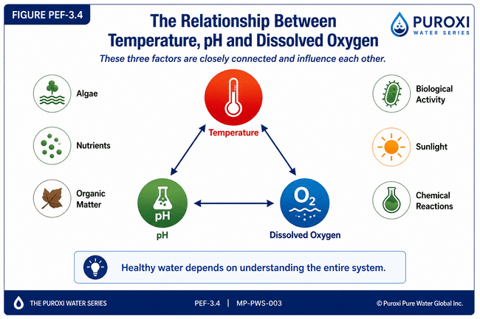

Healthy Water Depends on Understanding the Entire System

PUROXI PRINCIPLE
Water behaves as an interconnected system. When one condition changes, many others respond. Successful water management begins by understanding those relationships rather than managing individual numbers in isolation.

CHAPTER 6

pH and Water Treatment
Understanding pH is valuable.
Understanding how pH affects water treatment is essential.
Many water treatment problems are not caused by selecting the wrong equipment or treatment process. Instead, they occur because the water chemistry is not suitable for that process to perform at its best.
One of the first questions we ask before recommending any treatment technology is:
"Is the water chemistry helping or limiting the treatment process?"
That question often leads to a completely different solution.

pH and Oxidation
Oxidation is one of the most common processes used in water treatment.
It is used to:
- Remove iron.
- Remove manganese.
- Control odours.
- Improve water clarity.
- Reduce colour.
- Improve biological conditions.
- Support disinfection.
The efficiency of many oxidation processes depends heavily on water chemistry, particularly pH.
Changing the pH can significantly influence how quickly and effectively oxidation reactions occur.
Understanding this relationship often allows treatment systems to perform more efficiently while reducing operating costs.

pH and Hydrogen Peroxide
Hydrogen peroxide has been one of the core technologies used by Puroxi for many years.
Through practical field experience, we learned that the effectiveness of hydrogen peroxide is influenced by several factors, including:
- pH
- Temperature
- Organic loading
- Contact time
- Water chemistry
- Biological activity
Hydrogen peroxide should never be viewed as a product that works independently.
It works within the chemistry of the water.
Understanding that chemistry allows it to be used more effectively.

pH and Chlorine
Chlorine remains one of the world's most widely used disinfectants.
Its performance, however, depends greatly on water chemistry.
As pH changes, the balance between chlorine's active and less active forms also changes, influencing disinfection efficiency.
For this reason, understanding pH is an important part of designing and operating effective chlorination systems.

pH and Ozone
Ozone is one of the strongest oxidizing agents available for water treatment.
Its performance is influenced by many factors, including:
- Water chemistry
- Contact time
- Organic loading
- Temperature
- pH
Understanding these relationships allows ozone systems to be optimized for different applications.

pH and Nanobubbles
Nanobubbles have introduced new opportunities for improving water quality.
Their ability to improve gas transfer, increase dissolved oxygen, and support biological processes makes them an important technology across many industries.
Like every other treatment technology, nanobubbles perform within the chemistry of the water.
Understanding pH, dissolved oxygen, temperature, and biological activity helps maximize their effectiveness.

pH and Ultraviolet (UV)
Ultraviolet disinfection is primarily influenced by water clarity, UV transmittance, and system design.
Although pH generally has less direct influence on UV than on some chemical treatment processes, it still forms part of the overall water chemistry that determines treatment performance.
Successful water treatment considers the complete system rather than a single technology.

The Complete Water System
One of the most valuable lessons we have learned over the years is that no treatment technology should be evaluated in isolation.
Hydrogen peroxide.
Ozone.
Nanobubbles.
Ultraviolet.
Filtration.
Oxidation.
All work within the chemistry of the water.
Changing the chemistry changes the performance.
That is why understanding water always comes before recommending equipment.

THE FOUNDER'S NOTEBOOK

The Water Decides
Over the years, customers have often asked us:
"Which treatment system is the best?"
My answer has remained remarkably consistent.
The best treatment system is the one that matches the water.
No technology is universally the best.
Every technology has strengths.
Every technology has limitations.
The water determines which approach is most appropriate.
That is why we begin every project by asking questions before making recommendations.
The better we understand the water, the better we can select the most effective solution.

PUROXI INSIGHT
The effectiveness of any treatment technology depends not only on the equipment itself, but also on the chemistry of the water in which it is operating.

DID YOU KNOW?
Two identical treatment systems installed on different water sources can produce completely different results because each water source has its own unique chemistry.

PRACTICAL TIP
Before changing equipment, changing chemicals, or increasing dosage rates, review the complete water chemistry.
In many cases, improving the water conditions allows the existing treatment process to perform significantly better.

QUOTE
The best treatment system is not the most expensive or the most advanced. It is the one that best matches the water it is treating.

CHAPTER 7

pH in Everyday Applications
One of the reasons pH is so important is that it influences almost every use of water.
Whether the water is intended for drinking, raising livestock, irrigating crops, producing food, supporting aquatic life, manufacturing products, or treating wastewater, pH plays an important role.
However, one of the greatest misconceptions in water treatment is the belief that one pH range is ideal for every application.
It isn't.
Different objectives require different water conditions.
The key is understanding what the water needs to accomplish before deciding whether adjustment is necessary.

Drinking Water
For most people, water quality begins at the kitchen tap.
Safe drinking water depends on many factors, including microbiological quality, mineral content, taste, odour, clarity, and overall chemistry.
pH influences several of these characteristics, including corrosion, scaling, treatment efficiency, and consumer acceptance.
The objective is not simply to reach a number.
The objective is to provide water that is safe, stable, and pleasant to drink.

Agriculture
Water is often called the forgotten nutrient in agriculture.
Plants depend upon water not only for hydration but also for transporting nutrients throughout the plant.
Water chemistry influences nutrient availability, fertilizer efficiency, soil interactions, and overall crop performance.
Different crops and different growing conditions may respond differently to water chemistry.
Successful producers understand that water management is an important part of crop management.

Livestock Production
Water is the most overlooked nutrient on many farms.
Animals consume more water than any other nutrient, making water quality one of the most important factors influencing production.
Over many years of practical field experience, we learned that adjusting water chemistry to suit the specific application often improved overall production performance.
Rather than attempting to achieve one universal pH, we focused on creating water conditions that best supported the production objective.
This approach helped shift the conversation from:
"What should the pH be?"
to
"What water conditions best support healthy, efficient production?"
That philosophy continues to guide our recommendations today.

Aquaculture
In aquaculture, water is more than a drinking source.
It is the environment in which fish, shrimp, shellfish, and other aquatic organisms live every moment of their lives.
Changes in pH influence biological activity, dissolved oxygen, nutrient availability, ammonia toxicity, and the overall stability of the aquatic environment.
Maintaining stable water conditions is often more important than making frequent adjustments to reach one specific number.

Lakes and Reservoirs
Natural water bodies continuously change.
Daily sunlight.
Seasonal temperature.
Rainfall.
Wind.
Biological activity.
Nutrient loading.
All influence water chemistry.
When evaluating lakes, reservoirs, decorative ponds, or wastewater lagoons, pH should always be considered alongside dissolved oxygen, temperature, biological activity, and nutrient conditions.
Looking at only one parameter rarely provides the complete picture.

Municipal Water
Municipal treatment facilities manage large volumes of water serving entire communities.
Water chemistry influences treatment processes, infrastructure protection, regulatory compliance, and consumer satisfaction.
Maintaining consistent water quality requires understanding how all water quality parameters interact throughout the treatment and distribution system.

Industrial Water
Industry depends on water.
Manufacturing.
Food processing.
Mining.
Power generation.
Cooling systems.
Boilers.
Chemical production.
Every industrial process places different demands on water quality.
Understanding pH helps improve efficiency, protect equipment, reduce maintenance, and support reliable operation.

Wastewater Treatment
Wastewater treatment is one of the best examples of why water must be viewed as a complete system.
Biological treatment processes, oxidation, chemical reactions, nutrient removal, and odour control all respond to changing water chemistry.
Understanding pH alongside temperature, dissolved oxygen, alkalinity, and biological activity allows operators to make better operational decisions.

THE FOUNDER'S NOTEBOOK

Water Has a Job to Do
One of the most important lessons water taught us was this:
Every water source has a job.
Sometimes that job is producing healthy livestock.
Sometimes it is growing crops.
Sometimes it is raising fish.
Sometimes it is cooling industrial equipment.
Sometimes it is protecting public health.
The objective always comes first.
Once we clearly understand what the water needs to accomplish, we can begin determining whether changes in water chemistry will help achieve that objective.
That simple philosophy has guided our recommendations for more than two decades.

PUROXI INSIGHT
Water should never be judged by one number. It should be evaluated by how well it performs the job it has been asked to do.

DID YOU KNOW?
The same water may perform exceptionally well in one application while performing poorly in another. The difference is often not the water itself, but the objective it is expected to support.

PRACTICAL TIP
Before adjusting pH, ask yourself three questions:
- What is this water being used for?
- What outcome am I trying to achieve?
- Will changing the water chemistry help accomplish that objective?
If you cannot clearly answer those questions, more information may be needed before making adjustments.

PULL QUOTE
The purpose of water treatment is not to create perfect numbers. The purpose is to create water that performs its intended job as effectively as possible.

CHAPTER 8

Common Myths About pH
Few water quality parameters are misunderstood as often as pH.
Over the years, we have spoken with thousands of homeowners, farmers, municipalities, consultants, and industrial operators. One thing quickly became apparent:
Many decisions were being made based on misconceptions rather than science.
Understanding what pH does not tell us is just as important as understanding what it does.
Let's examine some of the most common myths.

Myth #1

"pH 7 Is Always Perfect"
This is probably the most common misconception in water treatment.
While a pH of approximately 7 is considered neutral under standard laboratory conditions, neutrality does not automatically mean it is the best pH for every application.
Different objectives require different water chemistry.
The ideal pH for a drinking water system may not be the same as that for irrigation, livestock production, aquaculture, wastewater treatment, or an industrial process.
Rather than asking,
"Is the pH 7?"
Ask,
"Is this water performing the job it needs to do?"

Myth #2

"If the Water Looks Clear, It Must Be Clean"
For many years, people judged water simply by looking at it.
If it was clear...
It must be good.
Today we know that is not true.
Many contaminants are invisible.
Many microorganisms cannot be seen.
Many dissolved minerals produce no colour at all.
Water may appear crystal clear while still containing undesirable constituents.
At Puroxi, we often say:
Clear water is not always clean.

Myth #3

"If the Water Is Clean, It Must Be Nutritional"
This is another misconception we encountered repeatedly.
Water may satisfy drinking water standards and still not provide the optimum chemistry for agriculture, livestock, aquaculture, or crop production.
Meeting minimum standards and optimizing performance are two different objectives.
Understanding that difference changes the entire conversation.

Myth #4

"pH Never Changes"
Nothing could be further from the truth.
Water is constantly responding to:
- Temperature
- Rainfall
- Groundwater recharge
- Carbon dioxide
- Biological activity
- Seasonal conditions
- Human activity
As these conditions change, pH often changes with them.
Water is dynamic.
Not static.

Myth #5

"One Laboratory Report Tells Me Everything"
A laboratory report provides valuable information.
But it represents only one sample collected at one moment in time.
Water continues changing long after the laboratory report has been completed.
Understanding trends over time is often more valuable than relying on a single report.

Myth #6

"One Number Explains Everything"
Perhaps the biggest misconception of all is believing that one water quality parameter tells the complete story.
It doesn't.
pH.
Temperature.
Dissolved oxygen.
Alkalinity.
Hardness.
Conductivity.
Biological activity.
Nutrients.
Each contributes to the overall behaviour of the water.
The real understanding comes from examining how they work together.

THE FOUNDER'S NOTEBOOK

The Biggest Mistake We Can Make
One of the biggest mistakes I have seen throughout my career is making decisions based on assumptions instead of understanding.
Assuming clear water is clean.
Assuming one laboratory report tells the whole story.
Assuming one pH fits every application.
Assuming one treatment technology works everywhere.
Water has taught us to question assumptions.
Every project begins with learning.
Every recommendation begins with understanding.
That philosophy has served both our customers and our company well for many years.

PUROXI INSIGHT
The more we learn about water, the more we realize that simple answers rarely solve complex water problems.

DID YOU KNOW?
Two water sources can have exactly the same pH and still behave completely differently because of differences in temperature, dissolved oxygen, alkalinity, hardness, mineral content, biological activity, and countless other factors.

PRACTICAL TIP
Whenever someone tells you there is one perfect number or one universal solution for water treatment, ask:
"Under what conditions?"
Water science is about understanding relationships—not memorizing numbers.

PULL QUOTE
Good water management begins the moment we stop making assumptions and start asking better questions.
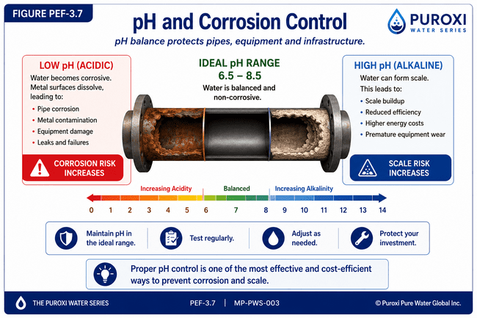

MYTHS vs FACTS
Split into two columns.

MYTHS
❌ pH 7 is always perfect.
❌ Clear water is clean.
❌ Clean water is nutritional.
❌ pH never changes.
❌ One laboratory report tells the whole story.
❌ One number explains everything.

FACTS
✅ Different applications require different water chemistry.
✅ Clear water can still contain contaminants.
✅ Clean water is not always optimized for production.
✅ Water chemistry changes continuously.
✅ Trends are more valuable than single measurements.
✅ Water behaves as an interconnected system.

Treatment Performance

CHAPTER 9

Practical Tips for Managing pH
Understanding pH is important.
Managing it effectively is even more important.
One of the greatest lessons water has taught us is that successful water management rarely comes from reacting to a single laboratory result. It comes from developing good habits, asking better questions, and understanding how water changes over time.
The following practical recommendations are based on scientific principles and years of field experience across agriculture, aquaculture, industry, municipal water systems, environmental water management, and drinking water applications.

Start by Understanding Your Water
Before making any changes, understand the source of your water.
Ask yourself:
- Is it groundwater?
- Is it surface water?
- Does it come from a municipal supply?
- Has it recently changed?
- What seasonal influences affect it?
Every successful water treatment program begins by understanding the source.

Never Rely on One Test
A single laboratory report is valuable.
Several laboratory reports collected over time are far more valuable.
Water changes continuously.
Seasonal monitoring allows you to identify trends before they become problems.
Whenever possible, maintain a historical record of your water quality.
The water itself will often reveal important patterns.

Record More Than pH
When testing water, don't stop at pH.
Also record:
- Water temperature
- Dissolved oxygen
- Conductivity
- Hardness
- Alkalinity
- Iron
- Manganese
- Colour
- Odour
- Water clarity
- Weather conditions
- Time of year
These observations often explain changes that pH alone cannot.

Understand Before You Adjust
One of the biggest mistakes in water treatment is adjusting water chemistry before understanding why it changed.
A changing pH is often a symptom.
Not the problem.
Before making corrections, determine what caused the change.
Treating the cause usually produces better long-term results than simply correcting the symptom.

Define Your Objective
Every adjustment should have a purpose.
Ask yourself:
What am I trying to accomplish?
Am I trying to improve:
- Production?
- Water quality?
- Animal health?
- Crop performance?
- Equipment protection?
- Treatment efficiency?
Clear objectives lead to better decisions.

Monitor the Results
Whenever changes are made to water chemistry, monitor the results carefully.
Observe the water.
Observe the equipment.
Observe the production system.
Observe the animals.
Observe the crops.
Water management is an ongoing process of observation, learning, and refinement.

Protect Your Investment
Water treatment equipment performs best when the water itself is understood.
Routine maintenance.
Routine testing.
Routine observation.
These simple practices often prevent costly problems before they occur.
Good water management protects both the water and the investment made in treatment equipment.

Continue Learning
Water science continues to evolve.
New technologies.
New research.
New treatment methods.
New understanding.
One of the most valuable investments you can make is continuing your education.
The more you understand your water, the more confident your decisions become.

THE FOUNDER'S NOTEBOOK

Water Rewards Those Who Pay Attention
One thing I have learned over the years is that water is remarkably consistent.
It always follows the laws of nature.
If something changes, there is usually a reason.
The challenge is taking the time to find it.
The producers who consistently achieve the best results are not necessarily those with the most expensive equipment.
They are usually the ones who observe their water, keep good records, ask questions, and continually learn from what the water is telling them.
Water rewards people who pay attention.

PUROXI INSIGHT
Good water management is not built on reacting to problems. It is built on understanding trends, asking questions, and making informed decisions before problems develop.

DID YOU KNOW?
Many of the most expensive water problems begin as small changes that go unnoticed. Regular observation and routine monitoring often identify these changes long before they become costly.

PRACTICAL CHECKLIST
Before making any adjustment to your water, ask yourself:
☐ Do I understand my water source?
☐ Have I confirmed the laboratory results?
☐ Have I looked at other water quality parameters?
☐ Do I understand why the pH changed?
☐ Have I clearly defined my objective?
☐ Am I treating the cause rather than the symptom?
☐ Do I have a plan to monitor the results?
If you answered "No" to any of these questions, gather more information before making significant changes.

PULL QUOTE
The best water managers are not the ones who react the fastest. They are the ones who understand the water the best.

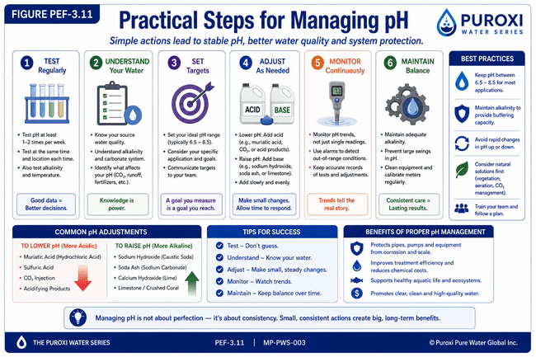
Successful water management is an ongoing process of observation, understanding, adjustment, and continuous improvement.

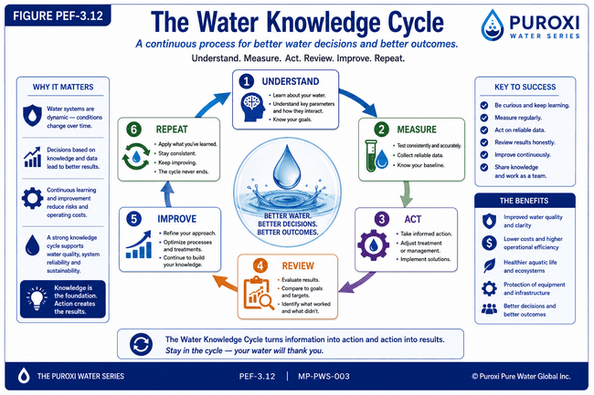

CHAPTER 10

What Is Your Water Trying to Tell You?
Every water source has a story.
Throughout this publication we have explored one of the most important chapters of that story—pH.
We have learned that pH is much more than a number on a laboratory report.
It influences chemistry.
Biology.
Treatment efficiency.
Corrosion.
Scale formation.
Agriculture.
Aquaculture.
Industry.
Drinking water.
And the overall health of aquatic environments.
Most importantly, we have learned that pH should never be viewed in isolation.
It is one part of a much larger conversation taking place within the water.
Understanding that conversation is where successful water management begins.

Learning to Read the Story
Imagine picking up a book and reading only one sentence.
You might understand a few words.
But you would never understand the story.
Water is much the same.
A single pH reading tells us something.
A laboratory report tells us more.
Years of observation tell us even more.
When we combine laboratory testing with practical experience, seasonal observations, and an understanding of the water source, we begin to see the complete picture.
That picture allows us to make informed decisions rather than educated guesses.

The Questions We Should Be Asking
Instead of asking:
"Is my pH good?"
Perhaps we should ask:
- Why is my pH changing?
- What is influencing it?
- What other water quality parameters are changing at the same time?
- Is the water supporting the objective I am trying to achieve?
- What is my water trying to tell me?
Those questions often produce better answers than simply focusing on a number.

Water Is Constantly Teaching Us
One of the greatest privileges of working with water is that it is always teaching us something new.
Every customer.
Every farm.
Every lake.
Every reservoir.
Every wastewater plant.
Every industrial process.
Every aquaculture facility.
Every project adds another chapter to our understanding.
The moment we believe we know everything about water is usually the moment water teaches us something new.
That is why learning never stops.

The Puroxi Philosophy
At Puroxi, our philosophy has remained remarkably simple.
We do not begin with products.
We begin with questions.
We seek to understand the water before recommending a solution.
That philosophy has guided our work for more than two decades and continues to shape every publication in The Puroxi Water Series.
We believe:
Understanding comes before recommendation.
Observation comes before assumption.
Knowledge comes before action.
Because when we understand the water, better decisions naturally follow.

Looking Ahead
This publication has focused on one of the most important measurements in water science.
In future editions of The Puroxi Water Series, we will continue exploring the many factors that work together to influence water quality, including:
- Dissolved Oxygen
- Temperature
- ORP (Oxidation-Reduction Potential)
- Hardness
- Alkalinity
- Conductivity
- Iron and Manganese
- Biological Activity
- Water Treatment Technologies
- Nanobubbles
- Hydrogen Peroxide
- Ozone
- Ultrasonic Algae Control
Each publication builds upon the last.
Together they form the Puroxi Knowledge System.

THE FOUNDER'S NOTEBOOK

Water Has Been My Greatest Teacher
Over the years I have often been asked,
"What is the most important thing you have learned about water?"
My answer has changed very little.
Water will tell you almost everything you need to know if you take the time to understand it.
It does not speak through words.
It speaks through chemistry.
Through biology.
Through temperature.
Through dissolved oxygen.
Through pH.
Through observation.
The answers are usually there.
Our responsibility is to learn how to recognize them.
That is why I continue to believe that understanding water is one of the best investments anyone can make.
Not only because it helps solve today's problems.
But because it helps prevent tomorrow's.

THE PUROXI PRINCIPLE
Understanding always comes before recommendation.
Every successful water management program begins with understanding the water itself.
Before changing chemistry...
Before purchasing equipment...
Before increasing chemical dosage...
Before making expensive decisions...
Take the time to understand what the water is trying to tell you.
The water already knows the answer.
Our job is to learn how to listen.

PUROXI INSIGHT
Every water source has its own fingerprint and DNA. Every water source has a story. The better we understand that story, the better our decisions become.

CONTINUE THE CONVERSATION
Every publication in The Puroxi Water Series is written to encourage curiosity, discussion, and a deeper understanding of water.
If this publication has caused you to think differently about pH or water chemistry, then it has achieved its purpose.
We invite you to:
- Share this publication with others.
- Discuss it with your colleagues.
- Ask questions.
- Challenge assumptions.
- Continue learning.
Knowledge grows when it is shared.

QUOTE
Water has all the answers. Our responsibility is to learn how to ask the right questions.

Water Is an Investment, Not an Expense
The better question is not 'What does water cost?' The better question is 'What value does better water create?'

THE PUROXI PRINCIPLE
Water should never be judged by what it costs.
It should be judged by the value it creates.
Continue the Conversation
What aspect of water quality is most often overlooked in your industry?
What topic should we cover next?
Email: info@puroxi.com
Subject: Please add me to the Puroxi Water Series

About Puroxi
Every water source is unique.
We begin by understanding your water.

Related Publications
Published: PWS-001
Published: PWS-002
Published: PWS-003
Coming Next: PWS-004- Understanding Dissolved Oxygen

Publication Information
Publication: PWS-003
Category: Water Science
Version: 1.0
First Edition: July 2026
Copyright © 2026 Puroxi Pure Water Global Inc.

