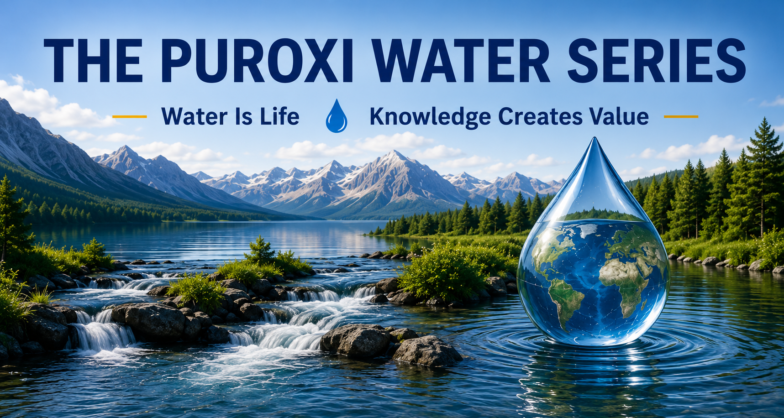
How Well Do You Really Know Your Water?
Publication Number: MP-PWS-002
Series: The Puroxi Water Series
Category: Water Science
First Edition: July 2026
Version: [1.0]
Published by Puroxi Pure Water Global Inc.
Water Is Life
Knowledge Creates Value

About This Publication

About This Publication
This publication is written for anyone who depends on water—whether at home, on a farm, in industry, in aquaculture, or within a municipality.
Water is one of the most important resources on Earth, yet it is often one of the least understood. Every water source has its own characteristics, its own history, and its own challenges.
The purpose of this publication is to help readers better understand why no two water sources are exactly alike and why understanding your water is the first step toward making better decisions.

AT A GLANCE

Estimated Reading Time
8–10 Minutes

This Publication Is Written For
✓ Homeowners
✓ Farmers
✓ Aquaculture Producers
✓ Municipalities
✓ Industry
✓ Consultants
✓ Students
✓ Anyone who depends on water

Key Takeaways
• Every water source has its own fingerprint and DNA.
• Water changes continuously.
• A water analysis is only the beginning.
• Good sampling practices are essential.
• Understanding your water is one of the best investments you can make.

THE PUROXI PRINCIPLE
Understanding always comes before recommendation.

Every Glass of Water Has a Story
Every day, billions of people turn on a faucet, fill a glass, water crops, care for livestock, raise fish, manufacture products, or operate municipal water systems.
Water is so familiar that we rarely stop to think about it.
Yet every drop has travelled an extraordinary journey.
Some water began as snow high in the mountains.
Some spent decades moving slowly through underground aquifers.
Some flowed through forests, farmland, lakes, and rivers before reaching its destination.
Along that journey, water collected minerals, dissolved gases, microorganisms, organic matter, and countless characteristics that make it unlike any other source.
Every drop carries a story.
Understanding that story is the first step toward understanding your water.

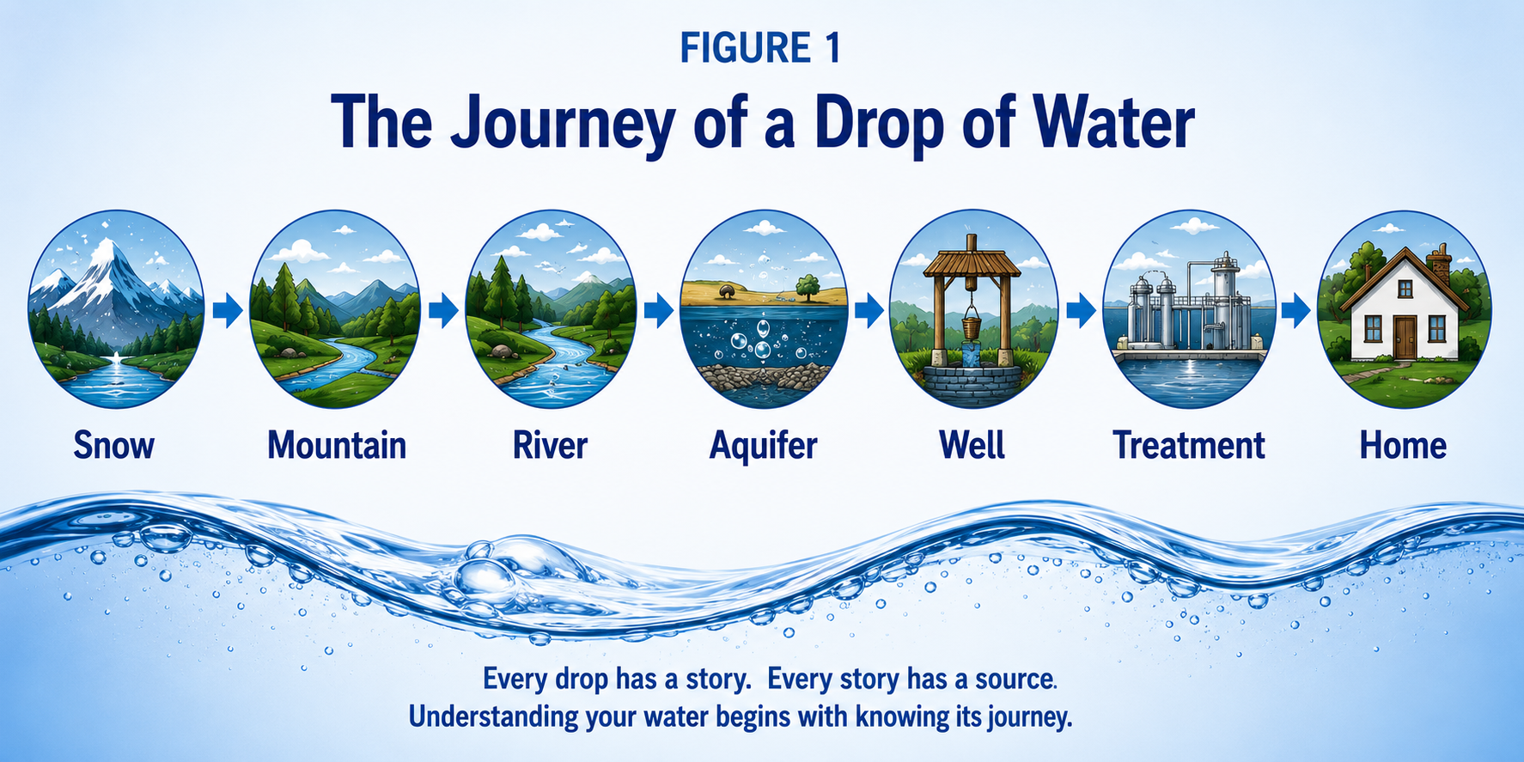

Every Water Source Has Its Own Fingerprint and DNA
Just as every person has unique fingerprints and DNA, every water source has its own identity.
No two wells are exactly alike.
No two lakes are exactly alike.
No two rivers are exactly alike.
Even neighbouring properties drawing groundwater from different depths may have completely different water chemistry.
Every water source develops its own unique characteristics based on:
- Local geology
- Rainfall
- Snowmelt
- Surface runoff
- Groundwater recharge
- Agricultural activity
- Industrial activity
- Biological activity
- Seasonal changes
- Time
This unique combination creates the fingerprint of the water.
That is why successful water management begins with understanding your own water—not someone else's.

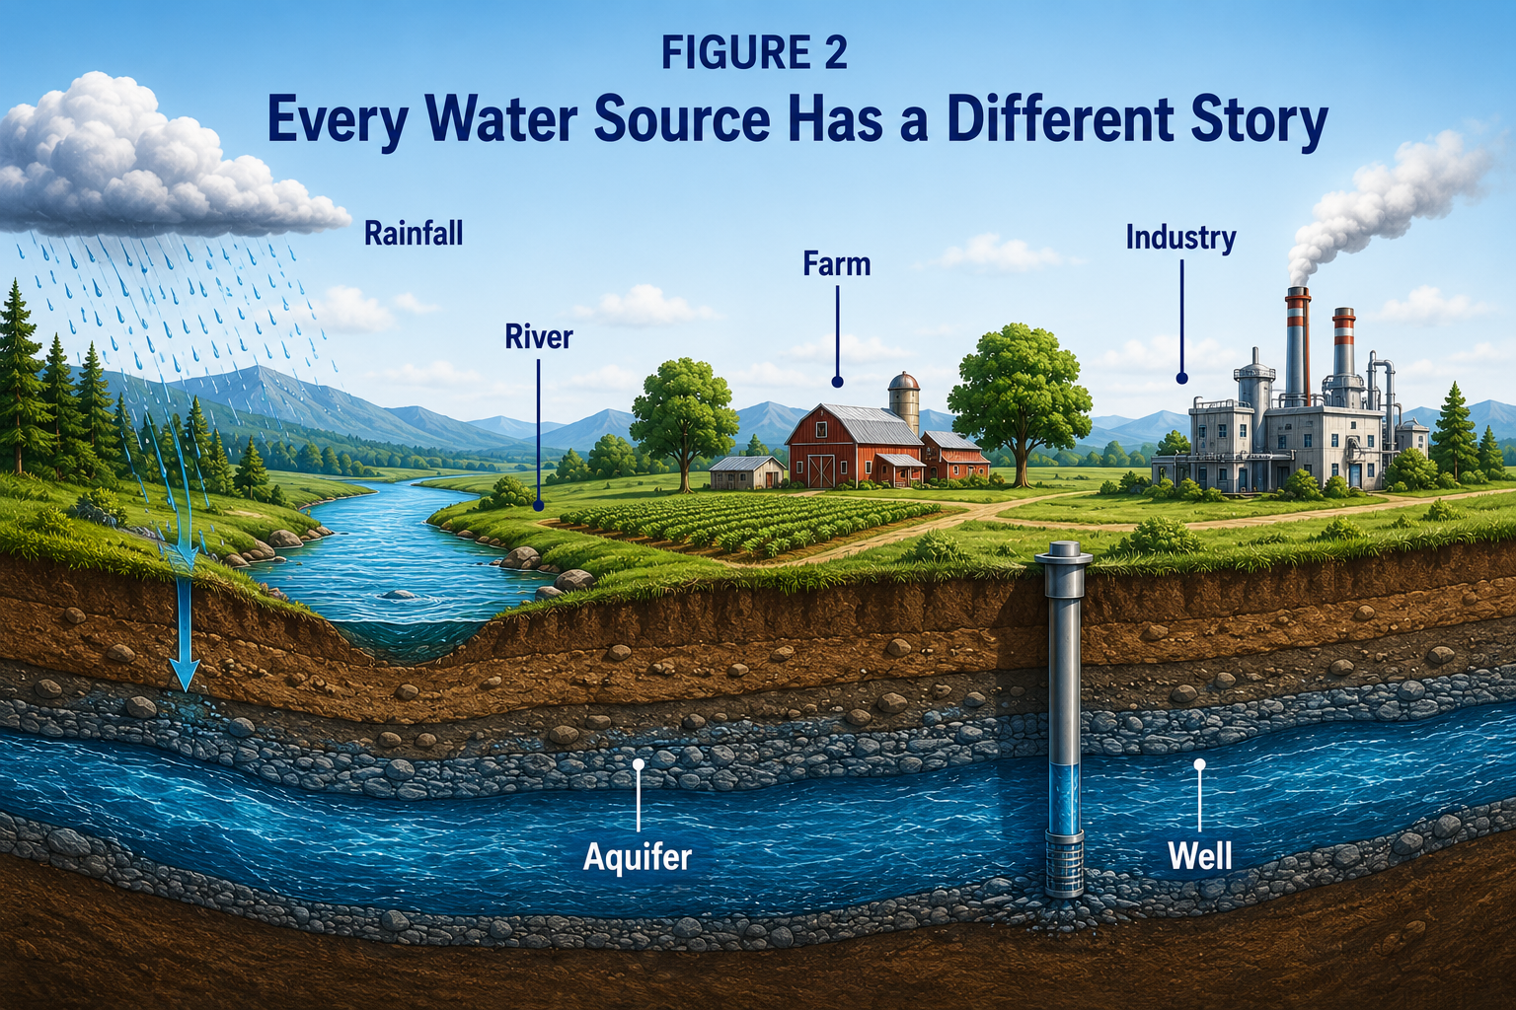

Water Never Stands Still
Many people assume their water remains the same throughout the year.
In reality, water is constantly changing.
Heavy rainfall may increase turbidity and introduce additional organic matter.
Spring snowmelt changes flow rates and nutrient loading.
Summer temperatures reduce dissolved oxygen while encouraging algae growth and biological activity.
Autumn introduces leaves and organic matter, while changing temperatures may cause lakes to undergo seasonal turnover.
Winter often brings more stable groundwater conditions, although surface waters continue to change.
Every season changes the fingerprint of your water.
Understanding those changes helps explain why water analyses performed at different times may produce different results.

DID YOU KNOW?
Water collected from the same location in January may produce noticeably different laboratory results than water collected from that same location in July.
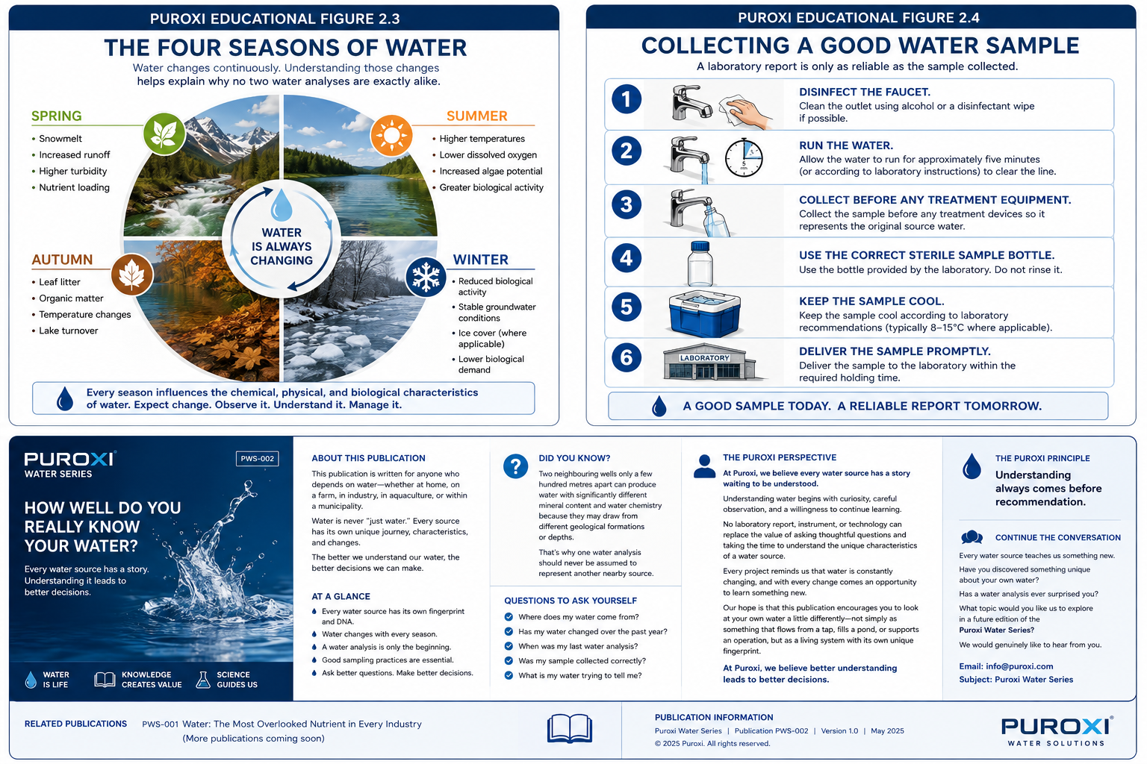

A Water Analysis Is Only the Beginning
A laboratory report provides valuable information, but it is only the beginning of understanding a water source.
Testing every possible bacterium, every dissolved mineral, every metal, every organic compound, and every potential contaminant would be technically possible in many situations—but it would also be impractical and unnecessarily expensive for most applications.
Instead, laboratories analyze the parameters most relevant to the purpose of the investigation.
A laboratory report becomes an excellent starting point.
Not the final answer.

Collecting a Good Water Sample
Even the world's best laboratory can only analyze the sample it receives.
Before collecting a sample, ask yourself:
✓ Was the faucet disinfected before sampling?
✓ Was the water allowed to run according to laboratory instructions?
✓ Was the sample collected before any treatment equipment?
✓ Was the correct sterile bottle used?
✓ Was the sample kept cool?
✓ Was the sample delivered to the laboratory within the recommended holding time?
A good laboratory report begins with a good sample.

What Is My Water Trying to Tell Me?
Perhaps the most valuable question we can ask is not:
"What treatment do I need?"
Instead, ask:
"What is my water trying to tell me?"
Water leaves clues.
Changes in colour.
Taste.
Odour.
Scale formation.
Corrosion.
Algae growth.

Fish behaviour.
Livestock performance.
Equipment wear.
Each observation tells part of the story.
The more carefully we observe, the better we understand.
And the better we understand, the better decisions we make.

Questions to Ask Yourself
- Where does my water come from?
- Has my water changed over the past year?
- When was my last water analysis?
- Was my sample collected correctly?
- What is my water trying to tell me?

The Puroxi Perspective
At Puroxi, we believe every water source has a story waiting to be understood.
Water rewards curiosity. The more we observe, test, question, and learn, the more clearly we understand its unique characteristics.
Every project reminds us that water is constantly changing. No single report, instrument, or technology can replace thoughtful observation and a genuine desire to understand what the water is telling us.
Our hope is that this publication encourages you to look at your own water differently—not simply as something that comes from a tap, fills a pond, or supports an operation, but as a living system with its own fingerprint and history.
At Puroxi, we believe better understanding leads to better decisions.

Continue the Conversation
Every water source teaches us something new.
What has your own water taught you?
Have you discovered something unique about your water source?

What topic would you like us to explore in a future edition of the Puroxi Water Series?
We would genuinely like to hear from you.
If you would like to receive future editions of the Puroxi Water Series, simply email:
info@puroxi.com
Subject: Please add me to the Puroxi Water Series

Related Publications

Published
PWS-001
Water: The Most Overlooked Nutrient in Every Industry

Coming Next
PWS-003
What Does a Water Analysis Really Tell You?

Publication Information
Publication: MP-PWS-002
Title: How Well Do You Really Know Your Water?
Series: The Puroxi Water Series
Category: Water Science
Version: 1.0
Published by: Puroxi Pure Water Global Inc.
Copyright © 2026 Puroxi Pure Water Global Inc. All rights reserved.
they can make better decisions.

