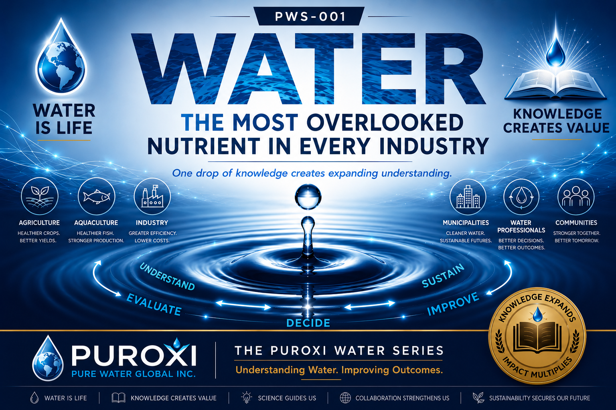

THE PUROXI WATER SERIES
PWS-001
Water: The Most Overlooked Nutrient in Every Industry
Category: Water Science
First Edition | July 2026
Published by Puroxi Pure Water Global Inc.
Water Is Life
Knowledge Creates Value

About the Puroxi Water Series
The Puroxi Water Series (PWS) is an educational publication designed to improve understanding of water through science, practical experience and thoughtful discussion.

AT A GLANCE
- Estimated Reading Time: 8 minutes
- Audience: Agriculture • Aquaculture • Municipalities • Industry • Consultants • Students
- Water is the foundation of life.
- Water quality influences every industry.
- Water is an investment.
- Every water source is unique.
- Better understanding leads to better decisions.

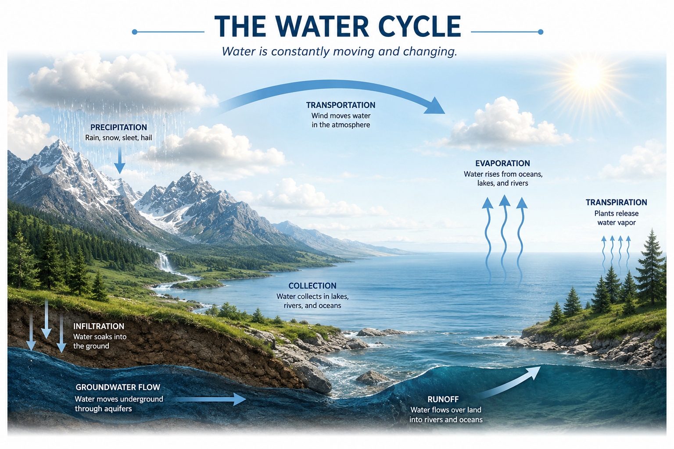

Why This Publication Matters
Without water, there would be no life. Every person, every animal, every crop, every fish, every forest and every ecosystem depends upon it. Water is the foundation upon which life itself depends. Around the world, investment in water treatment and reuse reflects its growing importance. Yet one question remains: Do we truly understand the water we depend upon every day?

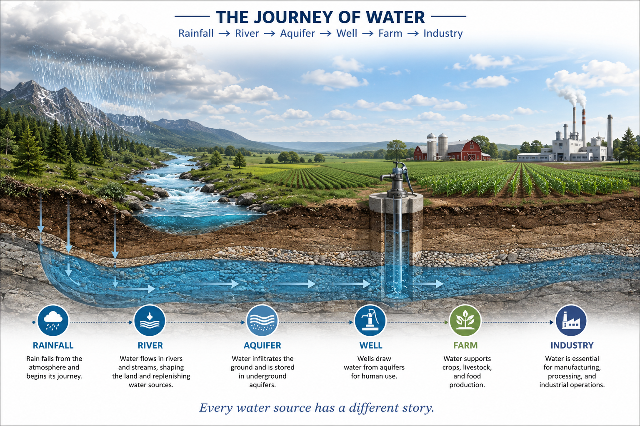

Water Is More Than H₂O
Water is the environment in which life exists and functions. It transports nutrients, carries dissolved oxygen, regulates temperature and removes metabolic waste. Everything begins with water.

PUROXI NOTE
Water is the environment in which life exists and functions.

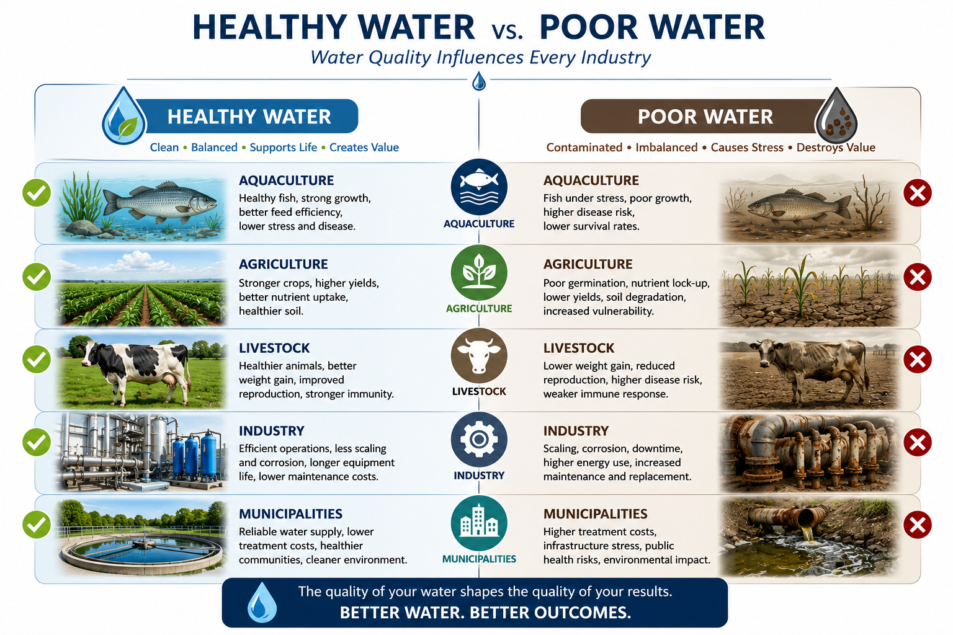

Water Quietly Influences Your Results
Good water quality creates opportunities. Poor water quality quietly works against production, health, efficiency and equipment longevity.
Better Biological Outcomes | Better Operational Outcomes
Healthier livestock | Longer equipment life
Healthier fish | Lower maintenance
Better crop yields | Reduced operating costs
Improved production | Greater sustainability

Water Is an Investment, Not an Expense
The better question is not 'What does water cost?' The better question is 'What value does better water create?'

THE PUROXI PRINCIPLE
Water should never be judged by what it costs.
It should be judged by the value it creates.

Continue the Conversation
What aspect of water quality is most often overlooked in your industry?
What topic should we cover next?
Email: info@puroxi.com
Subject: Please add me to the Puroxi Water Series

About Puroxi
Every water source is unique.
We begin by understanding your water.

Related Publications
Published: PWS-001
Coming Next: PWS-002 - How Well Do You Really Know Your Water?

Publication Information
Publication: PWS-001
Category: Water Science
Version: 1.0
First Edition: July 2026
Copyright © 2026 Puroxi Pure Water Global Inc.

