PUROXI ULTRASONIC DESCALER
Chemical-Free Scale Management for Plumbing and Water Systems
WHAT IT DOES  Limescale commonly forms when temperature or pressure changes cause dissolved hardness minerals to crystallize and adhere to plumbing, heat exchangers, heating elements and other wetted surfaces.  The Puroxi Ultrasonic Descaler transmits a varying electrical field through the pipe and the water it carries. This encourages hardness minerals to form more stable suspended crystals that can travel with the water flow instead of readily attaching to equipment surfaces. Existing scale may gradually soften and erode as operating conditions permit. | 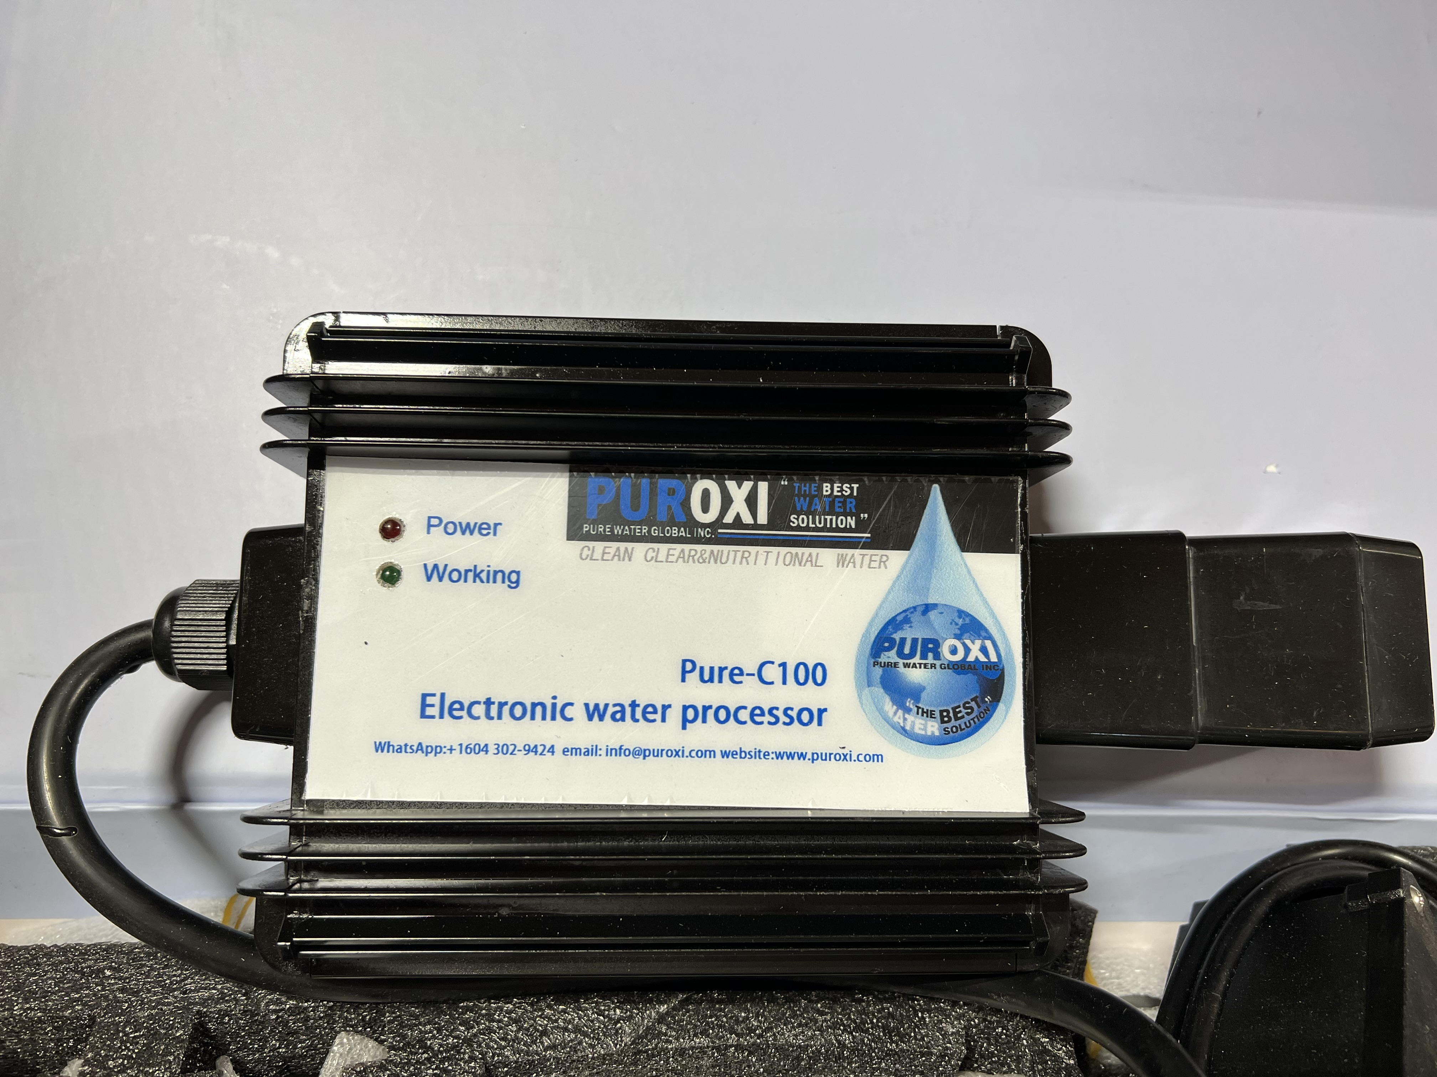  Typical Puroxi control unit
HOW THE SYSTEM SUPPORTS WATER MANAGEMENT
Scale control  Helps reduce new hard-scale attachment and supports gradual removal of existing deposits without cutting the pipe or adding treatment chemicals. | Biofouling & filtration  Depending on water chemistry and system design, the applied field may support biofouling control, particle flocculation and improved filtration performance. | Efficiency protection  Cleaner heat-transfer and filtration surfaces can help protect equipment efficiency and may reduce cleaning, backwash, water and energy demand.
INSTALLATION — COMPLETE ALL STEPS BEFORE APPLYING POWER
1. Select the location. Install on the pipe as close as practical to the scale problem. For boilers, chillers and heat exchangers, install on the cold-water inlet or upstream of the protected equipment.  2. Prepare the pipe. Remove insulation and thoroughly clean the outside pipe surface. The ceramics must contact the pipe directly; never place the unit or ceramics in water.  3. Mount carefully. Fit and secure the frame, control box and ceramic elements according to the model layout. Ceramics are fragile—do not strike, overtighten, break or strain the cables.  4. Inspect, then energize. Confirm every required ceramic element and cable is correctly installed before connecting power. Energizing the control box first can damage the equipment and void the warranty. | 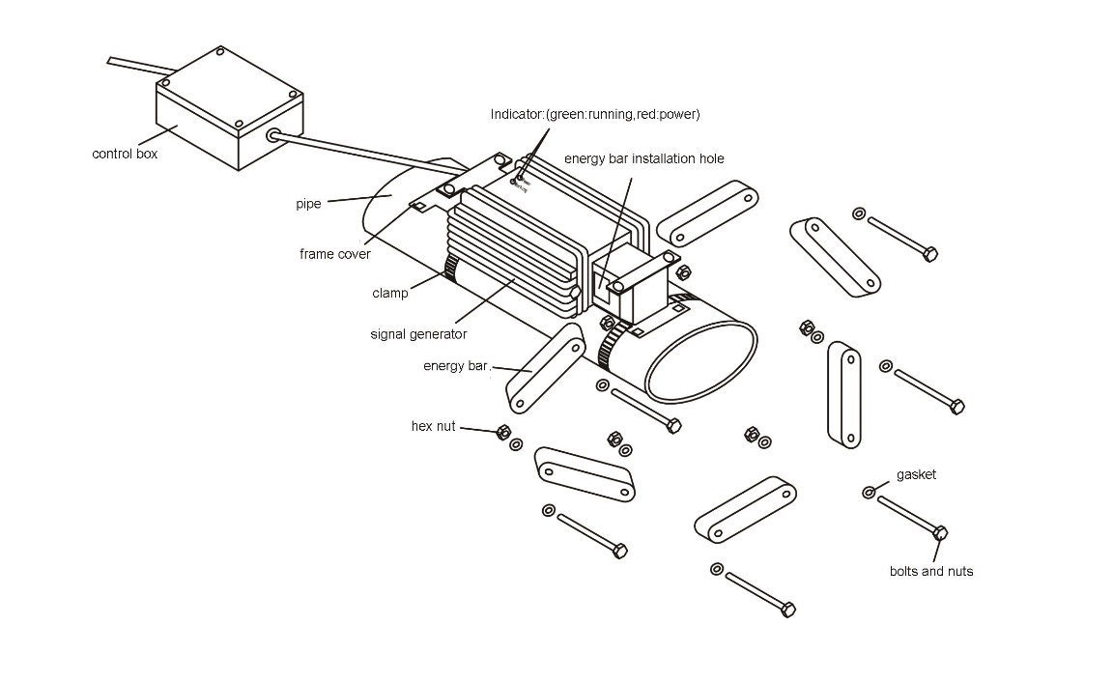  Typical frame and ceramic layout  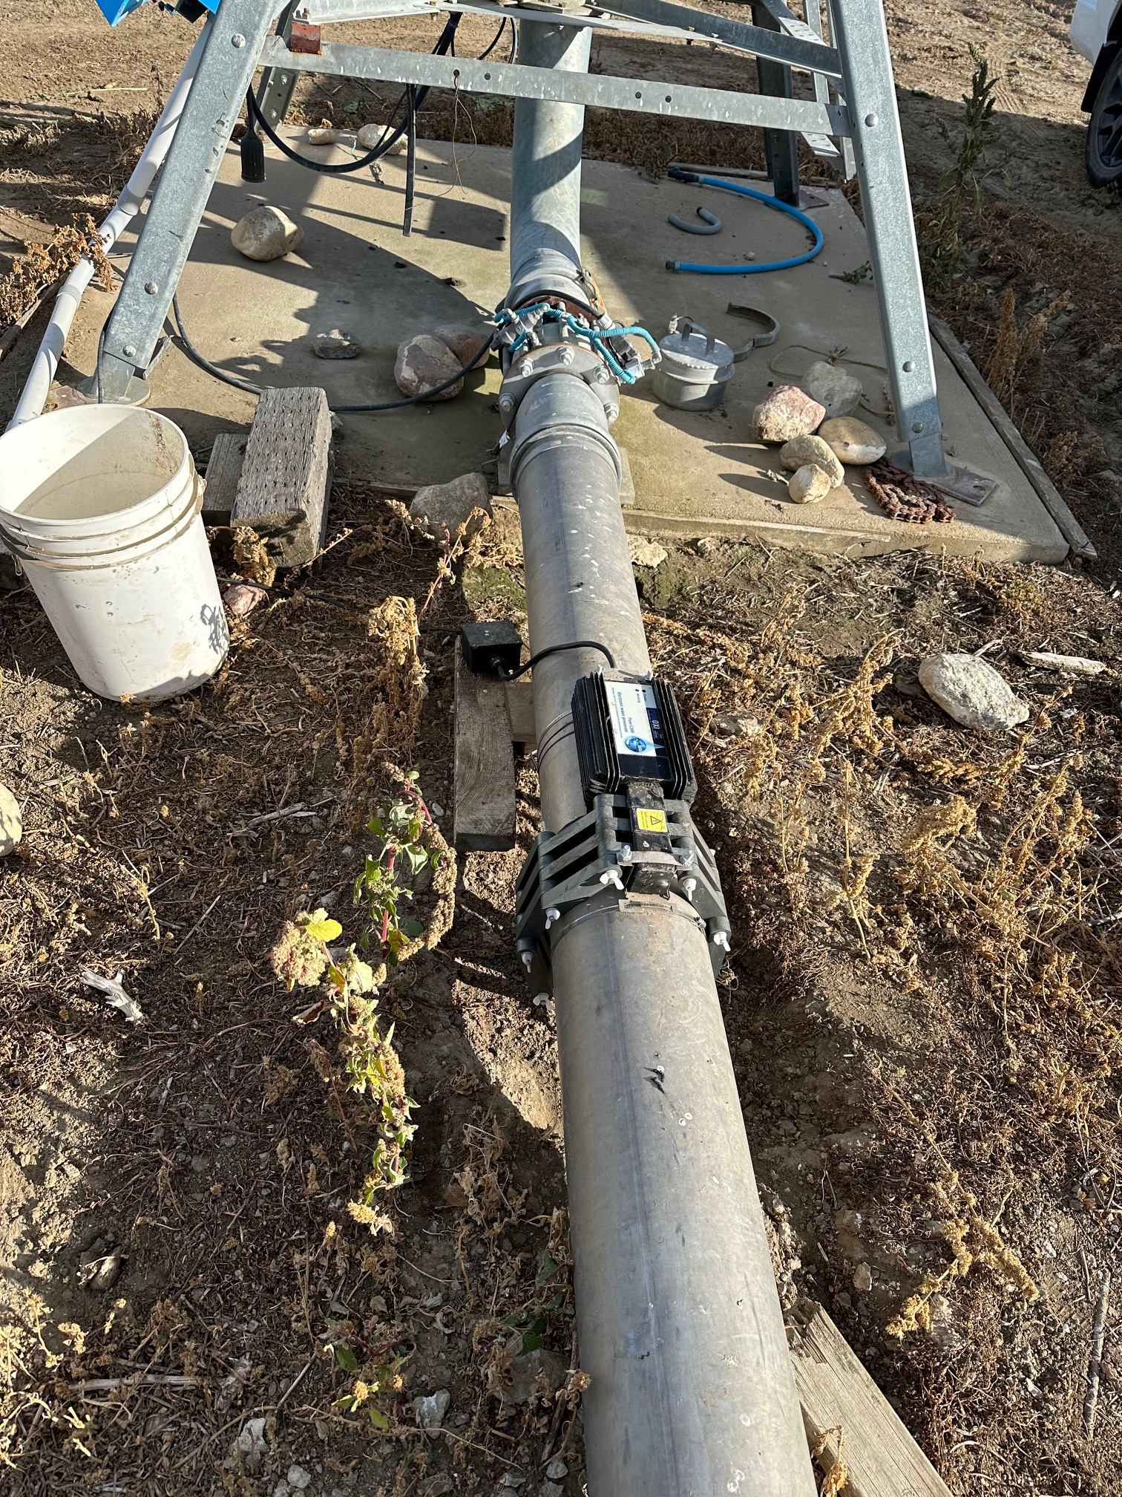  Installed directly on the pipe
ESSENTIAL OPERATING LIMITS
Input power | 90–240 VAC, 47–63 Hz | Control enclosure | Aluminium alloy; IP66
Environment | −20°C to 50°C; elevation <2,000 m | Relative humidity | Max. 50% at 40°C; max. 80% at 31°C
IMPORTANT SAFETY: Do not install where explosive or flammable gas may be present. Protect outdoor installations from rain and direct sun. Keep the control box and ceramics within the stated temperature limits. Use qualified electrical installation, grounding and surge protection. After a power interruption, confirm that the operating indicator is illuminated.
MODEL SELECTION: Pipe outside diameter, pipe material, layout, bends, branches, flow direction, temperature and water analysis are required for final sizing. This one-page guide does not replace the model-specific installation manual.

