Version 1.0
Design, Installation & Application Guide
Nano Bubble Nozzle Series
Puroxi® Technical Product Manual
Date: Monday, August 3, 2026
Subject: Puroxi® Nano Bubble Nozzle Technical Product Manual
Thank you for your interest in Puroxi Nano Bubble technology. Attached is the initial technical product manual summarizing our standard nozzle range. This document is intended to provide an overview of the available models, flow capacities, pressure requirements, oxygen transfer performance, ozone transfer capability, recommended pump sizes, materials, pricing, and ordering information.
This catalogue is the foundation of a much larger manual that will also include dimensional drawings, installation schematics, performance curves, product photographs, and application guides.
Thank you for the opportunity to understand your water.
Sincerely,
Puroxi Pure Water Global Inc.
Technical Note
This publication is intended as a technical product manual and application guide. It has been developed to assist customers, consultants, contractors, operators, and system designers in selecting and applying Puroxi® Nano Bubble Nozzles. All recommendations are based on product design characteristics, field experience, and application knowledge. Final system design should always consider the specific operating conditions of each installation.

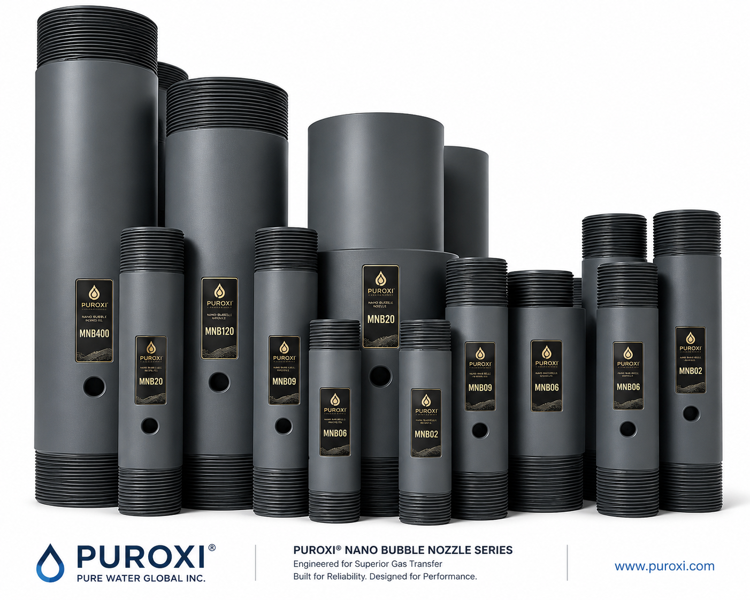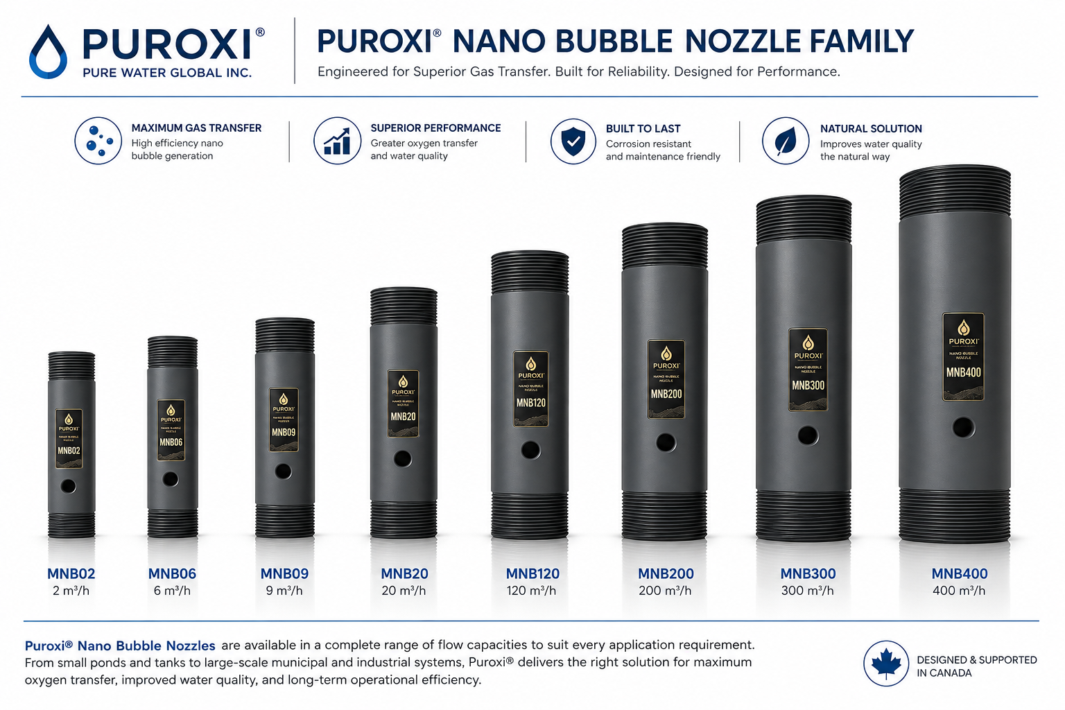

Table of Contents
MNB02 ........................................ 3
MNB06 ........................................ 4
MNB09 ........................................ 5
MNB20 ........................................ 6
MNB30 ........................................ 7
MNB40 ........................................ 8
MNB40S ........................................ 9
MNB50 ........................................ 10
MNB60 ........................................ 11
MNB60S ........................................ 12
MNB80 ........................................ 13
MNB100 ........................................ 14
MNB120 ........................................ 15
MNB150 ........................................ 16
MNB180 ........................................ 17
MNB250 ........................................ 18
MNB300 ........................................ 19
MNB400 ........................................ 20

Puroxi® Nano Bubble Nozzle – MNB02
Specification | Value
Flow Capacity (m³/h) | 2
Connections | 1-inch pipe size (Outer diameter = 1.315 inch)  No thread on nozzle ends
Recommended Pump | 80–150 W
Max Pressure (psi) | 100
Pure Oxygen Transfer (grams/hr) | 16–48
Ozone Transfer (L/hr) | 18–54
Natural Air O₂ (salinity/fresh grams/hr) | 13–15 / 10–12
Materials | UPVC, CPVC+PTFE, PTFE, SS304, SS316
Accessories | Gas fittings, 5 m tubing, flowmeter
Advantages | High oxygen transfer, low maintenance, no moving parts
Price (USD) | 375
Ordering Information: Contact Puroxi with water volume, application, water chemistry and desired turnover rate for final nozzle selection.

Puroxi® Nano Bubble Nozzle – MNB06
Specification | Value
Flow Capacity (m³/h) | 6
Connections | 1 1/4-inch pipe size (Outer diameter = 1.66 inch)  No thread on nozzle ends
Recommended Pump | 250–350 W
Max Pressure (psi) | 100
Pure Oxygen Transfer (grams /hr) | 48–144
Ozone Transfer (L/hr) | 54–162
Natural Air O₂ (salinity/fresh grams /hr) | 39–45 / 30–36
Materials | UPVC, CPVC+PTFE, PTFE, SS304, SS316
Accessories | Gas fittings, 5 m tubing, flowmeter
Advantages | High oxygen transfer, low maintenance, no moving parts
Price (USD) | 395
Ordering Information: Contact Puroxi with water volume, application, water chemistry and desired turnover rate for final nozzle selection.

Puroxi® Nano Bubble Nozzle – MNB09
Specification | Value
Flow Capacity (m³/h) | 9
Connections | 1 1/4-inch pipe size (Outer diameter = 1.66 inch)  No thread on nozzle ends
Recommended Pump | 450–550 W
Max Pressure (psi) | 100
Pure Oxygen Transfer (grams /hr) | 70–210
Ozone Transfer (L/hr) | 80–240
Natural Air O₂ (salinity/fresh grams /hr) | 65–75 / 50–60
Materials | UPVC, CPVC+PTFE, PTFE, SS304, SS316
Accessories | Gas fittings, 5 m tubing, flowmeter
Advantages | High oxygen transfer, low maintenance, no moving parts
Price (USD) | 410
Ordering Information: Contact Puroxi with water volume, application, water chemistry and desired turnover rate for final nozzle selection.

Puroxi® Nano Bubble Nozzle – MNB20
Specification | Value
Flow Capacity (m³/h) | 20
Connections | 1 1/2-inch pipe size (Outer diameter = 1.90 inch)  No thread on nozzle ends
Recommended Pump | 750–850 W
Max Pressure (psi) | 100
Pure Oxygen Transfer (grams /hr) | 140–520
Ozone Transfer (L/hr) | 160–480
Natural Air O₂ (salinity/fresh grams /hr) | 100–120 / 70–90
Materials | UPVC, CPVC+PTFE, PTFE, SS304, SS316
Accessories | Gas fittings, 5 m tubing, flowmeter
Advantages | High oxygen transfer, low maintenance, no moving parts
Price (USD) | 425
Ordering Information: Contact Puroxi with water volume, application, water chemistry and desired turnover rate for final nozzle selection.

Puroxi® Nano Bubble Nozzle – MNB30
Specification | Value
Flow Capacity (m³/h) | 30
Connections | 2-inch pipe size (Outer diameter = 1.913inch)  No thread on nozzle ends
Recommended Pump | 1.1–1.5 kW
Max Pressure (psi) | 100
Pure Oxygen Transfer (grams /hr) | 210–630
Ozone Transfer (L/hr) | 240–720
Natural Air O₂ (salinity/fresh grams /hr) | 170–200 /120–140
Materials | UPVC, CPVC+PTFE, PTFE, SS304, SS316
Accessories | Gas fittings, 5 m tubing, flowmeter
Advantages | High oxygen transfer, low maintenance, no moving parts
Price (USD) | 525
Ordering Information: Contact Puroxi with water volume, application, water chemistry and desired turnover rate for final nozzle selection.

Puroxi® Nano Bubble Nozzle – MNB40
Specification | Value
Flow Capacity (m³/h) | 40
Connections | 2-inch pipe size (Outer diameter = 2.50 inch)  No thread on nozzle ends, no flanges included
Recommended Pump | 1.5–2 kW
Max Pressure (psi) | 100
Pure Oxygen Transfer (grams /hr) | 320–960
Ozone Transfer (L/hr) | 360–1080
Natural Air O₂ (salinity/fresh grams /hr) | 225–270 /160–190
Materials | UPVC, CPVC+PTFE, PTFE, SS304, SS316
Accessories | Gas fittings, 5 m tubing, flowmeter
Advantages | High oxygen transfer, low maintenance, no moving parts
Price (USD) | 550
Ordering Information: Contact Puroxi with water volume, application, water chemistry and desired turnover rate for final nozzle selection.

Puroxi® Nano Bubble Nozzle – MNB40S
Specification | Value
Flow Capacity (m³/h) | 40
Connections | 3-inch pipe size (Outer diameter = 3.50 inch)  No thread on nozzle ends, no flanges included
Recommended Pump | 1.5–2 kW
Max Pressure (psi) | 100
Pure Oxygen Transfer (grams /hr) | 320–960
Ozone Transfer (L/hr) | 360–1080
Natural Air O₂ (salinity/fresh grams /hr) | 225–270 /160–190
Materials | UPVC, CPVC+PTFE, PTFE, SS304, SS316
Accessories | Gas fittings, 5 m tubing, flowmeter
Advantages | High oxygen transfer, low maintenance, no moving parts
Price (USD) | 550
Ordering Information: Contact Puroxi with water volume, application, water chemistry and desired turnover rate for final nozzle selection.

Puroxi® Nano Bubble Nozzle – MNB50
Specification | Value
Flow Capacity (m³/h) | 50
Connections | 3-inch pipe size (Outer diameter = 3.50 inch)  No thread on nozzle ends, no flanges included
Recommended Pump | 2.2–2.5 kW
Max Pressure (psi) | 100
Pure Oxygen Transfer (grams /hr) | 400–1200
Ozone Transfer (L/hr) | 450–1350
Natural Air O₂ (salinity/fresh grams /hr) | 290–310 /190–210
Materials | UPVC, CPVC+PTFE, PTFE, SS304, SS316
Accessories | Gas fittings, 5 m tubing, flowmeter
Advantages | High oxygen transfer, low maintenance, no moving parts
Price (USD) | 575
Ordering Information: Contact Puroxi with water volume, application, water chemistry and desired turnover rate for final nozzle selection.

Puroxi® Nano Bubble Nozzle – MNB60
Specification | Value
Flow Capacity (m³/h) | 60
Connections | 3-inch pipe size (Outer diameter = 3.50 inch)  No thread on nozzle ends, no flanges included
Recommended Pump | 3–3.5 kW
Max Pressure (psi) | 300
Pure Oxygen Transfer (grams /hr) | 480–1440
Ozone Transfer (L/hr) | 540–1620
Natural Air O₂ (salinity/fresh grams /hr) | 350–480 /230–350
Materials | UPVC, CPVC+PTFE, PTFE, SS304, SS316
Accessories | Gas fittings, 5 m tubing, flowmeter
Advantages | High oxygen transfer, low maintenance, no moving parts
Price (USD) | 595
Ordering Information: Contact Puroxi with water volume, application, water chemistry and desired turnover rate for final nozzle selection.

Puroxi® Nano Bubble Nozzle – MNB60S
Specification | Value
Flow Capacity (m³/h) | 60
Connections | 3-inch pipe size (Outer diameter = 3.50 inch)  No thread on nozzle ends, no flanges included
Recommended Pump | 3–3.5 kW
Max Pressure (psi) | 300
Pure Oxygen Transfer (grams /hr) | 480–1440
Ozone Transfer (L/hr) | 540–1620
Natural Air O₂ (salinity/fresh grams /hr) | 350–480 /230–350
Materials | UPVC, CPVC+PTFE, PTFE, SS304, SS316
Accessories | Gas fittings, 5 m tubing, flowmeter
Advantages | High oxygen transfer, low maintenance, no moving parts
Price (USD) | 595
Ordering Information: Contact Puroxi with water volume, application, water chemistry and desired turnover rate for final nozzle selection.

Puroxi® Nano Bubble Nozzle – MNB80
Specification | Value
Flow Capacity (m³/h) | 80
Connections | 4-inch pipe size (Outer diameter = 4.50 inch)  No thread on nozzle ends, no flanges included
Recommended Pump | 5–5.5 kW
Max Pressure (psi) | 250
Pure Oxygen Transfer (grams /hr) | 600–1900
Ozone Transfer (L/hr) | 700–2000
Natural Air O₂ (salinity/fresh grams /hr) | 440–500 /300–380
Materials | UPVC, CPVC+PTFE, PTFE, SS304, SS316
Accessories | Gas fittings, 5 m tubing, flowmeter
Advantages | High oxygen transfer, low maintenance, no moving parts
Price (USD) | 695
Ordering Information: Contact Puroxi with water volume, application, water chemistry and desired turnover rate for final nozzle selection.

Puroxi® Nano Bubble Nozzle – MNB100
Specification | Value
Flow Capacity (m³/h) | 100
Connections | 4-inch pipe size (Outer diameter = 4.50 inch)  No thread on nozzle ends, no flanges included
Recommended Pump | 5.5–7.5 kW
Max Pressure (psi) | 250
Pure Oxygen Transfer (grams /hr) | 800–2400
Ozone Transfer (L/hr) | 900–2600
Natural Air O₂ (salinity/fresh grams /hr) | 580–620 /380–420
Materials | UPVC, CPVC+PTFE, PTFE, SS304, SS316
Accessories | Gas fittings, 5 m tubing, flowmeter
Advantages | High oxygen transfer, low maintenance, no moving parts
Price (USD) | 725
Ordering Information: Contact Puroxi with water volume, application, water chemistry and desired turnover rate for final nozzle selection.

Puroxi® Nano Bubble Nozzle – MNB120
Specification | Value
Flow Capacity (m³/h) | 120
Connections | 4-inch pipe size (Outer diameter = 4.50 inch)  No thread on nozzle ends, no flanges included
Recommended Pump | 7.5–9 kW
Max Pressure (psi) | 250
Pure Oxygen Transfer (grams /hr) | 960–2880
Ozone Transfer (L/hr) | 1000–3200
Natural Air O₂ (salinity/fresh grams /hr) | 700–960 /460–700
Materials | UPVC, CPVC+PTFE, PTFE, SS304, SS316
Accessories | Gas fittings, 5 m tubing, flowmeter
Advantages | High oxygen transfer, low maintenance, no moving parts
Price (USD) | 795
Ordering Information: Contact Puroxi with water volume, application, water chemistry and desired turnover rate for final nozzle selection.
• Smaller MNB models typically have two gas ports.
• MNB120 and Larger models, including the MNB120 and above, have multiple gas ports around the nozzle.
• Air or oxygen must be distributed to every gas port on the selected model.

Puroxi® Nano Bubble Nozzle – MNB150
Specification | Value
Flow Capacity (m³/h) | 150
Connections | 4-inch pipe size (Outer diameter = 4.50 inch)  No thread on nozzle ends, no flanges included
Recommended Pump | TBD
Max Pressure (psi) | 250
Pure Oxygen Transfer (grams /hr) | See engineering
Ozone Transfer (L/hr) | See engineering
Natural Air O₂ (salinity/fresh grams /hr) | See engineering
Materials | UPVC, CPVC+PTFE, PTFE, SS304, SS316
Accessories | Gas fittings, 5 m tubing, flowmeter
Advantages | High oxygen transfer, low maintenance, no moving parts
Price (USD) | 825
Ordering Information: Contact Puroxi with water volume, application, water chemistry and desired turnover rate for final nozzle selection.

Puroxi® Nano Bubble Nozzle – MNB180
Specification | Value
Flow Capacity (m³/h) | 180
Connections | 4-inch pipe size (Outer diameter = 4.50 inch)  No thread on nozzle ends, no flanges included
Recommended Pump | TBD
Max Pressure (psi) | 250
Pure Oxygen Transfer (grams /hr) | See engineering
Ozone Transfer (L/hr) | See engineering
Natural Air O₂ (salinity/fresh grams /hr) | See engineering
Materials | UPVC, CPVC+PTFE, PTFE, SS304, SS316
Accessories | Gas fittings, 5 m tubing, flowmeter
Advantages | High oxygen transfer, low maintenance, no moving parts
Price (USD) | 825
Ordering Information: Contact Puroxi with water volume, application, water chemistry and desired turnover rate for final nozzle selection.

Puroxi® Nano Bubble Nozzle – MNB250
Specification | Value
Flow Capacity (m³/h) | 250
Connections | 6-inch pipe size (Outer diameter = 6.625 inch)  No thread on nozzle ends, no flanges included
Recommended Pump | 20–22 kW
Max Pressure (psi) | 250
Pure Oxygen Transfer (grams /hr) | 1920–5760
Ozone Transfer (L/hr) | 2000–6400
Natural Air O₂ (salinity/fresh grams /hr) | 1400–1920 /920–1400
Materials | UPVC, CPVC+PTFE, PTFE, SS304, SS316
Accessories | Gas fittings, 5 m tubing, flowmeter
Advantages | High oxygen transfer, low maintenance, no moving parts
Price (USD) | 895
Ordering Information: Contact Puroxi with water volume, application, water chemistry and desired turnover rate for final nozzle selection.

Puroxi® Nano Bubble Nozzle – MNB300
Specification | Value
Flow Capacity (m³/h) | 300
Connections | 6-inch pipe size (Outer diameter = 6.625 inch)  No thread on nozzle ends, no flanges included
Recommended Pump | 20–22 kW
Max Pressure (psi) | 250
Pure Oxygen Transfer (grams /hr) | 1920–5760
Ozone Transfer (L/hr) | 2000–6400
Natural Air O₂ (salinity/fresh grams /hr) | 1400–1920 /920–1400
Materials | UPVC, CPVC+PTFE, PTFE, SS304, SS316
Accessories | Gas fittings, 5 m tubing, flowmeter
Advantages | High oxygen transfer, low maintenance, no moving parts
Price (USD) | 895
Ordering Information: Contact Puroxi with water volume, application, water chemistry and desired turnover rate for final nozzle selection.

Puroxi® Nano Bubble Nozzle – MNB400
Specification | Value
Flow Capacity (m³/h) | 400
Connections | 6-inch pipe size (Outer diameter = 6.625 inch)  No thread on nozzle ends, no flanges included
Recommended Pump | By design
Max Pressure (psi) | 150
Pure Oxygen Transfer (grams /hr) | Custom
Ozone Transfer (L/hr) | Custom
Natural Air O₂ (salinity/fresh grams /hr) | Custom
Materials | UPVC, CPVC+PTFE, PTFE, SS304, SS316
Accessories | Gas fittings, 5 m tubing, flowmeter
Advantages | High oxygen transfer, low maintenance, no moving parts
Price (USD) | 5140 SS304 / 6995 SS316
Ordering Information: Contact Puroxi with water volume, application, water chemistry and desired turnover rate for final nozzle selection.
MNB120 to MNB150 Micro-Nanobubble nozzle SS304 -$1300.00
MNB120 to MNB150 Micro-Nanobubble nozzle SS316 -$1900.00
MNB250 to MNB300 Micro-Nanobubble nozzle SS304 -$2825.00
MNB250 to MNB300 Micro-Nanobubble nozzle SS316 -$3840.00
MNB400 Micro-Nanobubble nozzle SS304-$5050.00
MNB400Micro-Nanobubble nozzle SS316 - $6850.00

General Ordering, Pressure Ratings & Delivery Information
- Pricing excludes shipping, GST (Canada), and, outside Canada, customs brokerage, VAT, import duties (where applicable), and shipping charges.
- Nano Bubble Nozzles are available in UPVC, CPVC + PTFE, PTFE, SS304 Stainless Steel, and SS316 Stainless Steel.
- UPVC nozzles from MNB02 to MNB50 typically have a maximum working pressure rating of 60–100 psi, depending on the model.
- UPVC nozzles from MNB60 are available with pressure ratings from 200–400 psi, depending on the application.
- UPVC nozzles from MNB80 to MNB400 are typically available with pressure ratings ranging from 250 psi down to 150 psi depending on model size.
- Higher pressure ratings can be manufactured for specific applications; however, additional manufacturing time may be required.
- Puroxi generally maintains inventory of the most common MNB02 through MNB120 models. Typical turnaround for stocked units is only a few business days.
- MNB150 through MNB400 generally require 20–30 days manufacturing lead time depending on model and quantity ordered. Single-unit orders may occasionally ship sooner.
- Courier transit time is additional to manufacturing lead time.
- A treated-water discharge manifold can direct flow into multiple zones.
- Additional branches create friction and resistance.
- A higher-capacity pump may be required.
- Final selection must use the pump curve, complete-system total dynamic head, branch count and required flow at every outlet.
- Gas Supply Tubing - Gas must be connected to every gas port on the selected Puroxi Nano Bubble Nozzle model. Each nozzle is supplied with 5 metres (16.4 ft) of gas tubing. If additional tubing is required, it can be purchased locally from an industrial hose and fittings supplier. These suppliers are commonly available in most regions and stock suitable tubing for air and oxygen service.
- Treated Discharge Manifold - A treated-water discharge manifold can direct nano-bubble-treated water toward multiple zones, but it adds friction and resistance. A higher-capacity pump may therefore be required, with final selection made from the pump performance curve using complete-system total dynamic head, number of branches and required flow at each outlet.

North American Connection Standards
To simplify installation and ensure compatibility with locally available piping systems, Puroxi® Nano Bubble Nozzles are available with different connection configurations depending on the material of construction.

UPVC and CPVC Nano Bubble Nozzles
For North American installations, Puroxi recommends that UPVC and CPVC nano bubble nozzles be supplied with smooth socket (spigot) ends rather than threaded connections.
The smooth ends are manufactured to standard pipe outside diameters and are designed to accept locally sourced slip fittings, including:
- Slip unions
- PVC or CPVC couplings
- Socket fittings
- Solvent-weld (glue) fittings
- Flange adapters
- Custom transition fittings
This approach allows installers to use locally available plumbing components that comply with regional plumbing standards and simplifies future maintenance or replacement.
Puroxi Recommendation: For most North American PVC and CPVC installations, smooth-end connections provide a more versatile and reliable installation than threaded plastic connections.

PTFE, HDPE, POM, Stainless Steel 304 and Stainless Steel 316 Nano Bubble Nozzles
Nano bubble nozzles are manufactured from PTFE, HDPE, POM, SS304, or SS316.
Available connection standards include:
- NPT (National Pipe Thread)
- BSPT / BSPP (British Standard Pipe)
- JIS (Japanese Industrial Standard)
- ANSI / ASME
- DIN
- ISO
- Custom thread specifications (available at extra cost upon request)
The appropriate connection standard should be specified at the time of ordering to ensure compatibility with the customer's piping system.

Engineering Note
Always verify the following before ordering:
- Pipe material
- Pipe outside diameter
- Connection standard
- Pressure rating
- Temperature requirements
- Chemical compatibility
- Local plumbing or engineering codes
Selecting the correct connection type during the design stage helps reduce installation time and eliminates the need for unnecessary adapters or modifications in the field.

The Puroxi Integrated Oxidation Process™
Step 1 – Chemical Oxidation (Optional)
Hydrogen peroxide is metered into the water using a peristaltic dosing pump.
Depending on the application, ozone, oxygen, carbon dioxide, nitrogen, or other gases may also be used.
Step 2 – Nano Bubble Activation
The Puroxi Nano Bubble Nozzle creates billions of nano bubbles while simultaneously producing extremely intense mixing.
This rapidly disperses the hydrogen peroxide (or other treatment chemicals) uniformly throughout the water.
The persistent nano bubbles provide long-lasting dissolved oxygen and extended gas-liquid contact that can support oxidation processes and biological activity.
Step 3 – Water Quality Improvement
Depending on the application, the combined process may help:
Improve oxidation efficiency.
Increase dissolved oxygen.
Support beneficial aerobic bacteria.
Improve biological treatment.
Reduce odors.
Assist with COD and BOD reduction.
Improve sludge digestion.
Improve water clarity.
Enhance overall treatment performance.
Then we add what you've been saying all along:
The treatment chemistry should be selected to suit the application. Hydrogen peroxide is often the preferred first choice because it is generally more economical, easier to store, safer to handle, and simpler to integrate than ozone. However, where higher oxidation potential is required, oxygen, ozone, carbon dioxide, nitrogen, or other gases can also be incorporated into the Puroxi Nano Bubble treatment process.

